
Report Cover
The Privacy and Civil Liberties Oversight Board
Agency Financial Report
Fiscal Year 2025

[T H I S P A G E I N T E N T I O N A L L Y L E F T B L A N K ]

Title page

The Privacy and Civil Liberties
Oversight Board
Agency Financial Report

FISCAL YEAR 2025

PRIVACY AND CIVIL LIBERTIES OVERSIGHT BOARD
800 N. CAPITOL STREET, NW
WASHINGTON, DC 20002

Cover photo credit: PCLOB/Laura Grasso
This report is available at https://www.pclob.gov/FinancialReports.
Send comments or questions to info@pclob.gov or to the mailing address above.


Agency Transmittal Letter
Agency Transmittal Letter
I am pleased to present the Privacy and Civil Liberties Oversight Board (PCLOB) Fiscal Year (FY) 2025 Agency Financial Report (AFR). PCLOB’s mission is to ensure that the executive branch’s efforts to prevent terrorism are balanced with the need to protect privacy and civil liberties. To accomplish that mission, PCLOB provides advice to other executive branch agencies and conducts oversight of counterterrorism authorities and programs. This AFR highlights the agency’s FY 2025 accomplishments and challenges.
PCLOB continued its work on a number of advice and oversight projects in FY 2025, marking the most productive year in the agency’s history. PCLOB issued reports on the National Counterterrorism Center, the Terrorist Watchlist, facial recognition technology in aviation security, authorities addressing foreign racially motivated extremism, and the Intelligence Community’s implementation of Executive Order 14086, Enhancing Safeguards for United States Signals Intelligence Activities. Among other things, PCLOB began working on an update to the agency’s 2023 report examining Section 702 of the Foreign Intelligence Surveillance Act, focusing on recent changes to the program. PCLOB also continued its examination into the government’s efforts to counter domestic terrorism and the Federal Bureau of Investigation’s (FBI’s) use of open source information.
PCLOB has successfully prioritized operational efficiency and responsible financial management. Key to this success was the implementation of the agency’s first performance framework. This new framework introduced data-driven metrics that directly align with the goals and objectives outlined in PCLOB’s 2022–2026 Strategic Plan, enabling the agency to more effectively measure, improve, and optimize its mission objectives.
PCLOB’s accomplishments in financial management and reliable reporting are noteworthy, underscoring our commitment to fiscal stewardship. Through continuous, disciplined efforts to enhance financial controls, maintain data integrity, and ensure the reliability of all financial reports, the agency received an unmodified (clean) audit opinion on PCLOB’s FY 2025 financial statements from its external auditor. Further, our assessment of PCLOB’s internal controls and financial management systems, as required by the Federal Managers’ Financial Integrity Act and the Office of Management and Budget’s Circular A-123, Management’s Responsibility for Enterprise Risk Management and Internal Control, enables PCLOB to provide reasonable assurance that the financial and performance information contained in this report is complete, reliable, and accurate.
I extend my heartfelt thanks and deep appreciation to the dedicated staff at PCLOB for their steadfast efforts in fulfilling the agency’s mission.

Beth A. Williams
Board Member
November 14, 2025

Table of Contents
Agency Transmittal Letter 1
Introduction 4
Management’s Discussion and Analysis 9
Mission and Organization Structure 10
Financial Position and Condition 12
FY 2025 Key Performance Results 20
Significant Opportunities and Risks 39
FY 2025 Management Assurance Statement 42
Analysis of Systems, Controls, and Legal Compliance 43
Financial Section 49
Message from the Chief Financial Officer 50
Independent Auditor’s Report 51
Audited Financial Statements 56
Notes to the Financial Statements 60
Other Information 76
Summary of FY 2025 Financial Statement Audit and Management Assurances 77
Payment Integrity Information Act of 2019 79
Fraud Reduction Act 81
Appendix: Abbreviations 82

Introduction
Introduction

About This Report

PCLOB’s FY 2025 AFR provides fiscal results and performance highlights for the reporting period beginning October 1, 2024, and ending September 30, 2025. This report enables the President, Congress, and the public to assess the agency’s fiscal accountability as PCLOB advances its mission of ensuring that efforts by the executive branch to protect the nation from terrorism are balanced with privacy and civil liberties.
The AFR is one of the performance and financial reports required from federal agencies, prepared in accordance with Office of Management and Budget (OMB) Circulars A-11, Preparation, Submission, and Execution of the Budget; A-123, Management’s Responsibility for Enterprise Risk Management and Internal Control; and A-136, Financial Reporting Requirements. The annual agency financial reports are available on the PCLOB website.

PCLOB’s Pathway to an Agency Financial Report
PCLOB’s first-ever financial statement audit in FY 2018 resulted in the auditor’s inability to render an audit opinion, prompting the development of a solid foundation of control activities, policies, and procedures to address the audit weaknesses identified. This diligence paid off, enabling the agency to obtain an unmodified (clean) audit opinion over PCLOB’s FY 2019 financial statements with no new audit findings and no required audit adjustments—a significant achievement for a small, maturing agency.

In FY 2020, as PCLOB continued to seek areas for operational improvement and growth by further refining and strengthening its accounting practices and appointing a Chief Financial Officer (CFO), the agency issued its first-ever AFR. PCLOB’s issuance of an AFR represented a significant achievement for the agency, indicating substantial growth in its capacity to not only achieve sound financial management but to faithfully report to the public in full compliance with guidelines and requirements established by OMB and other relevant entities.
Photo credit: Andrew S. via Adobe Stock
This FY 2025 report is the sixth AFR issued by PCLOB.
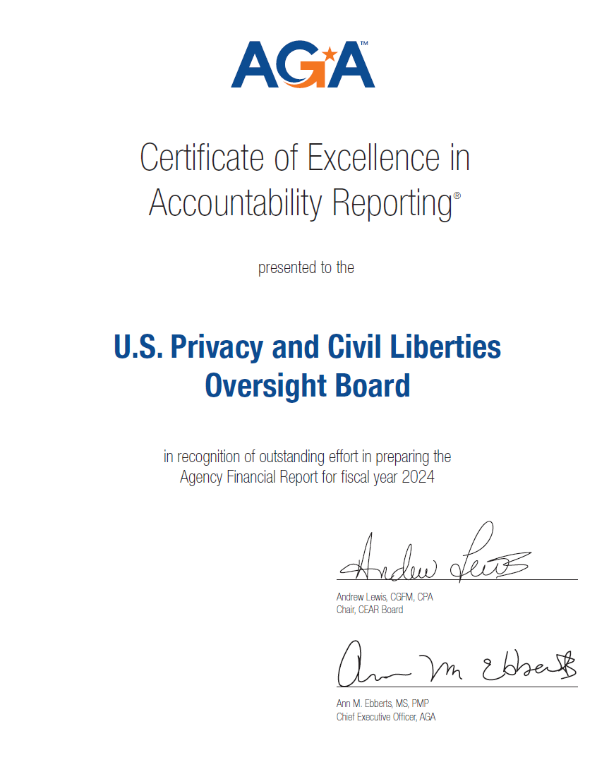

Certificate of Excellence in Accountability Reporting
In May 2025, PCLOB received the Certificate of Excellence in Accountability Reporting (CEAR) award from the AGA for its FY 2024 AFR. The CEAR is the highest form of recognition in Federal Government management reporting. AGA, a professional association with a vision for advancing governmental accountability, established the CEAR Program in conjunction with the Chief Financial Officers Council to further performance and accountability reporting. This is the third consecutive year PCLOB has received the prestigious CEAR award.


How This Report Is Organized
This AFR presents the agency’s performance highlights and accomplishments, fiscal accountability, operational achievements, and challenges for FY 2025. After the Agency Transmittal Letter and Introduction, the report features three sections and one appendix.
Management’s Discussion and Analysis
This section provides background about the agency, including PCLOB’s history, mission, organizational structure, and projects. It provides an overview of performance information, financial results, and management assurance regarding internal controls. This section is not audited by the independent auditor.
Financial Section
This section details the agency’s financial position as of the fiscal year that ended September 30, 2025. The agency’s FY 2025 audited financial statements and footnote disclosures are presented in this section, along with the independent auditor’s report.
- The independent auditor’s report speaks to whether the financial statements are materially stated in accordance with federal generally accepted accounting principles (GAAP). The auditor found PCLOB’s FY 2025 financial statements to be materially correct in accordance with U.S. GAAP.
- Financial statements provide actual financial results for the year and include the Balance Sheet, the Statement of Net Cost, the Statement of Changes in Net Position, and the Statement of Budgetary Resources. The following section, “Key Terms Used in This Report,” describes these statements and other financial terms.
- Notes to the financial statements provide additional details and context concerning the amounts reported.
Other Information
This section contains a summary of the financial statement audit, management assurances, and required reporting related to PCLOB’s compliance with the Payment Integrity Information Act, including the agency’s fraud reduction measures. This section is not audited.
Appendix
The appendix provides a list of abbreviations used throughout this report.

Key Terms Used in This Report
Generally Accepted Accounting Principles (GAAP) — GAAP refers to a common set of accounting principles, standards, and procedures used in the United States, as designated by the American Institute of Certified Public Accountants (AICPA). PCLOB follows the GAAP requirements for federal financial reporting issued for federal entities by the Federal Accounting Standards Advisory Board (FASAB).
Government Financial Statements — According to the U.S. Government Accountability Office (GAO), the objectives of federal financial reports are for agencies to demonstrate their accountability, provide useful information, and help internal users of financial information to improve the government’s management.
Balance Sheet — The Balance Sheet reports the agency’s assets and liabilities at a fixed point in time—September 30, 2025. Most of the terms on the Balance Sheet are familiar to users of financial statements. There is one unique term on a federal balance sheet: “Fund Balance with Treasury.” Like bank accounts, the fund balance represents the amount of funding in the agency's accounts within the U.S. Department of the Treasury (Treasury) that is available to spend for the purposes for which the funds were appropriated by Congress.
Statement of Net Cost — The Statement of Net Cost reports the results of operations. A commercial company would call this type of document an income statement. As a reflection that most federal programs generate little to no resources on their own, expenses are offset by revenues to determine the net cost for the agency. In the absence of revenues, total program costs represent recognized net cost.
Statement of Changes in Net Position — The Statement of Changes in Net Position is similar to a statement of changes in equity for a commercial firm. The statement reflects the impact that changes in assets and liabilities have on the agency’s financial position.
Cumulative Results of Operations — Cumulative Results of Operations are a component of net position on balance sheets representing the historical total for a fund, summing revenues, expenses, gains, losses, transfers of assets and liabilities from other agencies, and other financing sources provided to a fund since its inception. It is similar in concept to retained earnings for a commercial company.
Statement of Budgetary Resources — The Statement of Budgetary Resources reports on the key components of the budgetary control process. The statement shows the various sources of budgetary authority and resources provided to fund agency activities. Commercial companies have no similar statement or set of requirements to establish and control budgets in this manner.

Management’s Discussion and Analysis
Management’s Discussion and Analysis

Mission and Organization Structure

Our Mission
PCLOB’s mission is to ensure that the executive branch’s efforts to prevent terrorism are balanced with the need to protect privacy and civil liberties. Specifically, the agency’s enabling statute, 42 United States Code (U.S.C.) § 2000ee, authorizes it to “analyze and review actions the executive branch takes to protect the Nation from terrorism, ensuring that the need for such actions is balanced with the need to protect privacy and civil liberties,” and to “ensure that liberty concerns are appropriately considered in the development and implementation of laws, regulations, and policies related to efforts to protect the Nation against terrorism.”
PCLOB’s mission is to ensure that the executive branch’s efforts to prevent terrorism are balanced with the need to protect privacy and civil liberties.
PCLOB’s mission encompasses two core functions: providing advice and conducting oversight.
Advice — PCLOB has duties to review the development and implementation of proposed, new, and existing legislation, regulations, and policies related to efforts to protect the nation from terrorism and to provide advice to the President and the departments, agencies, and elements of the executive branch to ensure privacy and civil liberties protections are appropriately considered.
Oversight — PCLOB is charged with continually reviewing (1) regulations, policies, and procedures within the agency’s jurisdiction to ensure that privacy and civil liberties are protected; (2) the information sharing practices of the departments, agencies, and elements of the executive branch relating to efforts to protect the Nation from terrorism to determine whether they appropriately protect privacy and civil liberties and adhere to the information sharing guidelines issued or developed under subsections (d) and (f) of section 485 of title 6 and to other governing laws, regulations, and policies regarding privacy and civil liberties; and (3) other actions within the agency’s jurisdiction to ensure that those actions appropriately protect privacy and civil liberties and are consistent with governing laws, regulations, and policies regarding privacy and civil liberties.

PCLOB History and Authorities
PCLOB was created on the recommendation of the National Commission on Terrorist Attacks Upon the United States (the 9/11 Commission) in its 2004 report. The 9/11 Commission acknowledged that many of its recommendations “call[ed] for the government to increase its presence in our lives—for example, by creating standards for the issuance of forms of identification, by better securing our borders, by sharing information gathered by many different agencies,” and by consolidating authority over intelligence agencies under a new Director of National Intelligence. Recognizing that “this shift of power and authority to the government” would require “an enhanced system of checks and balances to protect the precious liberties that are vital to our way of life,” the 9/11 Commission recommended that “there should be a board within the executive branch to oversee adherence to the guidelines we recommend and the commitment the government makes to defend our civil liberties.”
Through the Intelligence Reform and Terrorism Prevention Act of 2004, Congress created a Privacy and Civil Liberties Oversight Board within the Executive Office of the President. In 2007, Congress established the Privacy and Civil Liberties Oversight Board in its current form through the Implementing Recommendations of the 9/11 Commission Act as an independent agency within the executive branch.
Transparency is an integral part of PCLOB’s mission. Specifically, PCLOB is required to inform the public about its work by holding public hearings, issuing public reports to the extent consistent with the protection of classified information and applicable law, providing semi-annual reports to Congress, and appearing and testifying before Congress upon request.
PCLOB also has designated roles under Executive Order (EO) 13636, Improving Critical Infrastructure Cybersecurity, Presidential Policy Directive 28, EO 14086, Enhancing Safeguards for United States Signals Intelligence Activities, and Section 803 of the Implementing Recommendations of the 9/11 Commission Act of 2007.

Our Organization
PCLOB is headquartered in Washington, DC. The Board comprises a bipartisan group of five Board Members: a full-time Chair and four part-time Members, each appointed by the President, with the advice and consent of the Senate, to staggered six-year terms. PCLOB’s statute requires that no more than three Members of the Board come from the same political party. At the end of FY 2025, with only one serving Member and four Member vacancies, the Board lacked quorum (defined as three Members). For information about the current and former Board Members and PCLOB’s sub-quorum policy, see PCLOB’s website.
In addition to the five Board Members, PCLOB comprises mission and operations staff, totaling fewer than 30 full-time employees at the end of FY 2025.

Financial Position and Condition

The financial summary and highlights that follow provide an overview of PCLOB’s 2025 financial statements. The independent auditor, Castro & Company, audited the agency’s Balance Sheet as of September 30, 2025, along with the Statements of Net Cost, Changes in Net Position, and Budgetary Resources for the fiscal year ended September 30, 2025. PCLOB received an unmodified audit opinion on its FY 2025 financial statements. Summary tables of key financial measures from the Balance Sheet and Statements of Net Cost, Changes in Net Position, and Budgetary Resources are provided. The complete financial statements, the independent auditor’s report, accompanying footnote disclosures, and required supplementary information are presented in the Financial Section of this report.
Photo credit: Andrea Izzotti via Adobe Stock
PCLOB prepared its financial statements from its accounting records in conformity with GAAP, which for federal entities, are the standards issued by the Federal Accounting Standards Advisory Board. The agency’s management is responsible for the integrity and objectivity of the financial information presented in the statements.
This section provides an overview of the causes of significant changes and trends in financial position as explained by the composition or balances of assets, liabilities, net position, costs, budgetary resources, and financing sources that appear on PCLOB’s financial statements, organized as follows:
- Balance Sheet: Overview of Financial Position;
- Statement of Net Cost;
- Statement of Changes in Net Position;
- Statement of Budgetary Resources; and
- Limitations of the Principal Financial Statements.

Balance Sheet: Overview of Financial Position
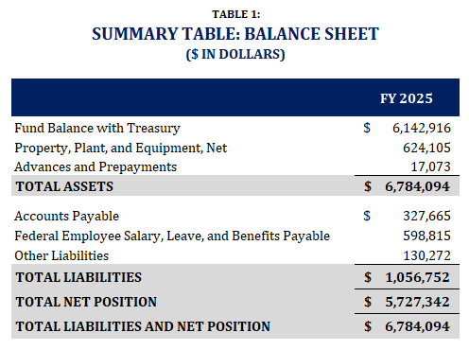
The Balance Sheet presents resources owned and managed by PCLOB that have future economic benefits (assets) and amounts owed by the agency that will require future payments (liabilities). The difference between assets and liabilities is the residual amount retained by PCLOB (net position) that is available for future programs. The Balance Sheet reports the major components of PCLOB’s assets, liabilities, and net position at the end of FY 2025 and is summarized above in Table 1, Summary Table: Balance Sheet.
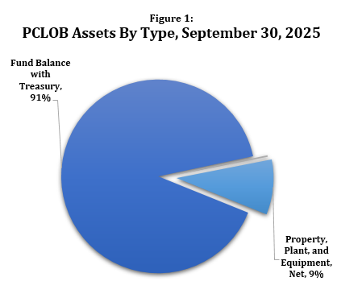
Assets
Assets are the amount of current and future economic benefits owned or managed by PCLOB used to achieve its mission. Total assets were approximately $6.8 million as of September 30, 2025, and are reported in three categories on the Balance Sheet: Fund Balance with Treasury (FBwT); Property, Plant, and Equipment, Net; and Advances and Prepayments.
As depicted in Figure 1, PCLOB Assets By Type, September 30, 2025, PCLOB’s most significant asset was the FBwT which represented approximately 91% of the agency’s total assets as of September 30, 2025. PCLOB’s other assets were property, plant, and equipment, net and advances and prepayments, representing 9% and less than 1%, respectively, of the total asset balance as of September 30, 2025.
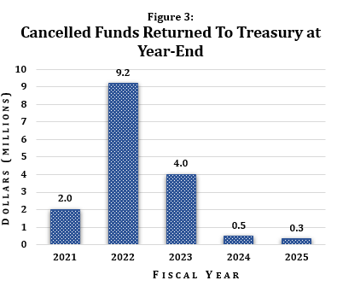
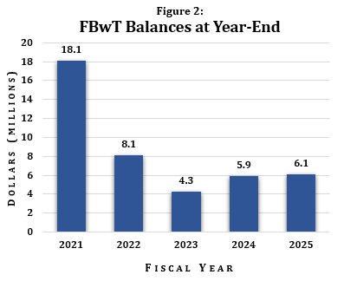
FBwT, which totaled $6.1 million as of September 30, 2025, consisted of cash appropriated to PCLOB by Congress or transferred from other federal agencies and held in Treasury accounts that are accessible by the agency to pay incurred obligations. As depicted in Figure 2, FBwT Balances at Year-End, the agency’s FBwT balances within the last few years have varied significantly from balances just five years ago. In FY 2016, PCLOB received a significantly larger appropriation of $21.3 million, which included funding for anticipated expenses to complete the build out and accreditation of a new Sensitive Compartmented Information Facility (SCIF) as well as associated moving expenses to the agency’s new headquarters location in Washington, DC. The agency managed to complete the move and all improvements to the property considerably well under budget; however, obligated funds associated with the project remained available for a five-year period to liquidate any associated project costs. After the passage of five years, however, the funds expired and became unavailable for obligation or expenditure for any purpose and were returned to Treasury. As PCLOB returned millions of cancelled funds to Treasury (see Figure 3, Cancelled Funds to Treasury at Year-End), the agency’s FBwT balance consequently decreased significantly. By FY 2024, PCLOB had returned all funds leftover from the FY 2016 appropriation; cancelled funds returned to Treasury at year’s end amounted to approximately $331 thousand in FY 2025. Ultimately, the proactive and deliberate effort to return millions of unused taxpayer dollars to the Treasury showcases PCLOB’s exemplary fiscal integrity as well as its steadily maturing financial resource management.
PCLOB’s remaining assets at the end of FY 2025, which included net property, plant, and equipment and advances and prepayments, collectively decreased from FY 2024. Net property, plant, and equipment, largely composed of leasehold improvements necessary to build the agency’s SCIF as well as other tangible assets such as equipment and furniture owned by the agency, decreased by approximately $275 thousand (31%), from approximately $900 thousand in FY 2024 to approximately $625 thousand in FY 2025 due to costs associated with the disposal of obsolete equipment and depreciation. Advances and prepayments for various contracted services and subscriptions decreased by approximately $81 thousand (83%), from approximately $98 thousand in FY 2024 to approximately $17 thousand in FY 2025. As PCLOB continued to transition contracts from one procurement service provider, the Department of the Interior, or DOI (which requires contract costs to be paid in advance), to another procurement service provider, the Administrative Resource Center (ARC), a federal shared service provider in the Treasury’s Bureau of the Fiscal Service, fewer advance contracts were necessary.
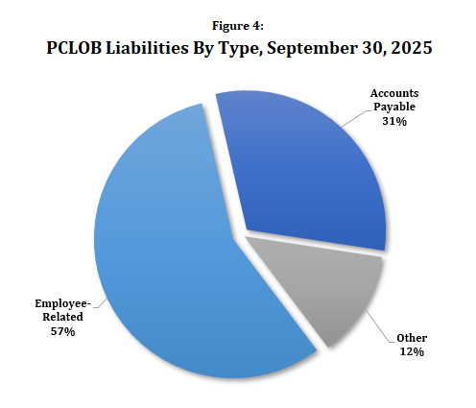
Liabilities
Liabilities are amounts owed by PCLOB for goods and services provided but not yet paid—specifically, monies owed to the public and other federal agencies. Liabilities are reported in three categories on the Balance Sheet, as depicted in Figure 4, PCLOB Liabilities by Type, September 30, 2025: Accounts Payable; Employee-Related Liabilities (i.e., Federal Employee Salary, Leave, and Benefits Payable), and Other Liabilities. The balances for all of PCLOB’s liabilities categories increased from FY 2024 to FY 2025. Total Accounts Payable increased approximately $28 thousand (9%), up from approximately $300 thousand as of September 30, 2024, to approximately $328 thousand as of September 30, 2025, related to amounts owed to vendors, trading partners, and other stakeholders for unbilled or unpaid goods and services delivered during normal operations. Employee-Related Liabilities increased approximately $100 thousand (20%), up from approximately $500 thousand as of September 30, 2024, to approximately $600 thousand as of September 30, 2025. This increase is associated with higher-than-usual accrued, unfunded leave balances for employees. Lastly, total Other Liabilities saw an increase of approximately $95 thousand (266%), up from approximately $35 thousand as of September 30, 2024, to approximately $130 thousand as of September 20, 2025, mostly related to an increase in contingent liabilities of $86 thousand.
Net Position
PCLOB’s net position, comprising unexpended appropriations and cumulative results of operations, appears on the Balance Sheet and the Statement of Changes in Net Position. Funds made available by Congress in FY 2025 in the amount of $13.7 million were recorded in Unexpended Appropriations. See the following section related to the Statement of Changes in Net Position for further analysis.
Statement of Net Cost
The Statement of Net Cost highlights the agency’s net cost of operations for a given fiscal year. Net cost of operations is the difference between a program’s gross cost and its related earned revenues. PCLOB’s earned revenues historically have come from reimbursable agreements with other federal agencies for temporary detail assignments of PCLOB employees; however, in FY 2025, earned revenues were zero, since PCLOB did not detail any employees out to other federal agencies under reimbursable agreements. Since PCLOB had no earned revenue, gross and net program costs are the same and can be referred to as “total” program costs on PCLOB’s Statement of Net Cost.
PCLOB is an independent agency within the executive branch, operating as a single entity (meaning, it does not combine with any other entities and does not have any components which would be consolidated). PCLOB’s two programs, Mission Activities and Operational Activities, are internally determined and based on the agency’s strategic goals. Net cost by program are depicted in Table 2, Summary Table: Statement of Net Cost.
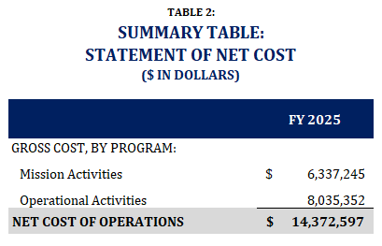
Mission activities program costs of approximately $6.4 million in FY 2025 consisted of salaries and related benefits expenses for Board Members, counselors, and mission staff as well as other costs associated specifically with the mission such as training, travel, and professional certifications. Operational activities program costs of approximately $8 million in FY 2025 included salaries and related benefits expenses for all operational staff as well as other overhead costs such as advisory and assistance services (e.g., shared services and systems maintenance); office rent; and supplies and equipment. Expenses associated with general counsel and legislative and public affairs (e.g., salaries and benefits, subscriptions, and certain services) of approximately $1.7 million in FY 2025 were allocated between mission and operational activities programs as these activities benefit the agency as a whole.
PCLOB’s total net cost of operations increased approximately $2.1 million (17%), up from approximately $12.3 million in FY 2024 to approximately $14.4 million in FY 2025. Most of the total increase in FY 2025 was directly related to salary and benefits expenses for additional mission staff hired in late FY 2024 and early FY 2025. Slight increases in office rent, shared service provider fees, and system maintenance costs also contributed to the overall increase in FY 2025 costs.
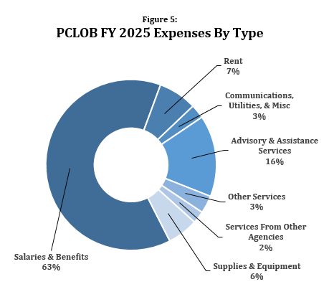
Figure 5, PCLOB FY 2025 Expenses By Type, depicts PCLOB’s major expense categories, with salaries and benefits of approximately $9 million (63%); advisory and assistance services of approximately $2.2 million (16%); and rent of approximately $1 million (7%) accounting for the agency’s most significant expenses.
Statement of Changes in Net Position
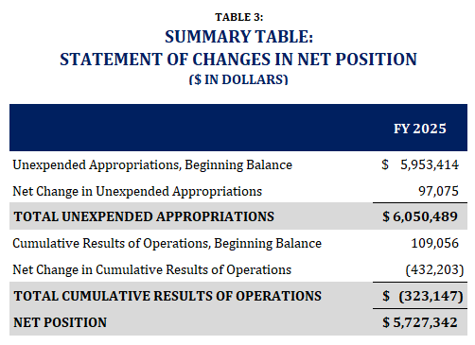
The Statement of Changes in Net Position identifies the differences between all financing sources available to and used by PCLOB to support its net cost of operations. Increases or decreases in an agency’s net financial position are the sum of two components: unexpended appropriations and cumulative results of operations. Each component is displayed separately to facilitate a more detailed understanding of the changes in net position as a whole. As seen in Table 3, Summary Table: Statement of Changes in Net Position, the reported net position balance as of September 30, 2025, was approximately $5.7 million, which was a slight decrease of approximately $335 thousand (or 6%) from the $6 million net position balance as of September 30, 2024. The primary contributing factor to the decrease in PCLOB’s net position was the agency’s increased net cost of operations (as seen on the Statements of Net Cost and Changes in Net Position), which caused the cumulative results of operations to decrease.

Statement of Budgetary Resources
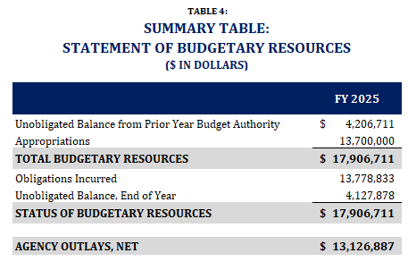
PCLOB’s Statement of Budgetary Resources details how the agency obtained its budgetary resources and the status of these resources at its fiscal year-end. PCLOB’s total budgetary resources consisted of new budget authority, which for PCLOB’s FY 2025 appropriation were available for obligation for two fiscal years, and unobligated balances of budget authority provided in previous years carried forward. New obligations and upward adjustments resulted from orders placed, contracts awarded, services received, or similar transactions which require payments during the same or future periods. Net outlays reflect the actual cash disbursed by Treasury for PCLOB’s obligations net of offsetting collections.
As shown in Table 4, Summary Table: Statement of Budgetary Resources, PCLOB’s total budgetary resources were approximately $17.9 million for FY 2025, of which $13.7 million came from new budget authority (unchanged from FY 2024 due to the full-year continuing resolution passed in FY 2025), and of which approximately $4.2 million came from unobligated balances carried forward. Unobligated balance from prior-year budget authority was higher than in previous years (approximately 4.2 million in FY 2025 compared to approximately $2.4 million in FY 2024), partially due to approximately $3.4 million of carryover funding from the FY 2024 appropriation which was not used per OMB-directed budget cuts in FY 2024. In FY 2025, net outlays increased approximately $1.5 million (13%), up from approximately $11.6 million to approximately $13.1 million, in alignment with the increase of expenses as reflected on the Statement of Net Cost.
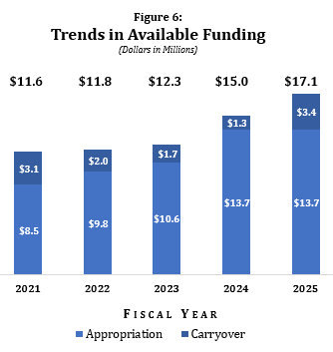
Figure 6, Trends in Available Spending, depicts the sources of PCLOB’s total available funding each year. PCLOB’s sources for funding have varied in recent years. Until the end of FY 2024, the carryover balance, available through the approval of two-year appropriations from year to year, had been decreasing as the agency’s financial management matured and improved. As mentioned above, however, the agency received guidance from OMB to make drastic cuts to its FY 2024 spending in anticipation of a significantly smaller FY 2024 appropriation than requested (forecasted at the time to be as much as 19% less than the requested $14.4 million). In response, PCLOB made difficult decisions to delay hiring much needed staff and procuring long overdue information technology (IT) hardware upgrades; limit staff training and business travel requests; and cut contracts for goods and services as much as possible. These cutbacks continued until the agency received its FY 2024 appropriation of $13.7 million in early April 2024—six months into the fiscal year. Many of the cutbacks were not able to be addressed during the remaining six months of the fiscal year, thus resulting in a higher-than-usual carryover balance available for FY 2025 use.

Limitations of the Principal Financial Statements
The principal financial statements are prepared to report the financial position, financial condition, and results of operations, pursuant to the requirements of 31 U.S.C. § 3515(b). The statements are prepared from records of the entity in accordance with federal GAAP and the formats prescribed by OMB. Reports used to monitor and control budgetary resources are prepared from the same records. Users of the statements are advised that the statements are for a component of the U.S. Government.
Photo credit: Tony Northrup via Adobe Stock

FY 2025 Key Performance Results
PCLOB holds an OMB-approved exemption from annual performance planning and reporting requirements of the Government Performance and Results Act (GPRA) of 1993, as amended by the GPRA Modernization Act of 2010, through FY 2030. Due to PCLOB’s small size, limited resources, and unique mission requirements, the agency’s small staff is unable to meet the full set of requirements imposed by GPRA without expending significant time, effort, and resources that detract from PCLOB’s ability to carry out its mission. However, recognizing the value of performance goals and measurement procedures, PCLOB endeavored to incorporate these elements into management’s current processes by rolling out its first structured performance framework in FY 2024.
The measures established under PCLOB’s performance framework correlate with the goals and objectives of the agency’s FY 2022–2026 Strategic Plan. For each measure in the agency’s performance framework, PCLOB sets annual targets to help drive continuous improvement. “On-track” measures are those where the target has been met or exceeded, while “off-track” measures represent areas that could benefit from further attention. Progress toward each measure’s annual target is assessed quarterly by senior leadership and reported to the Performance Improvement Officer (PIO) to promote continual advancement.
At the beginning of FY 2025, some performance measures were updated, combined or removed, based on management’s assessment of FY 2024 results as well as changes in the President’s agenda. The key performance results that follow are highlights of the agency’s first full year operating under a refined structured performance framework.

STRATEGIC GOAL 1: OVERSIGHT
Conduct effective oversight of executive branch authorities, policies, and activities related to efforts to protect the nation against terrorism to ensure appropriate protection of privacy and civil liberties.
Background
In its oversight function, the agency is required to “continually review” executive branch regulations, policies, procedures, information-sharing practices, and other actions related to efforts to protect the nation from terrorism to ensure that they appropriately protect privacy and civil liberties and comport with governing laws, regulations, and policies relating to privacy and civil liberties.
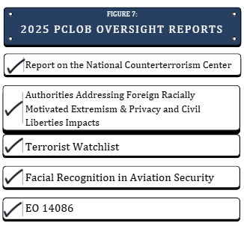
FY 2025 Accomplishments
In line with the agency’s first strategic goal, PCLOB conducted vigorous oversight of efforts by the executive branch to protect the nation against terrorism, examining both classified activities and unclassified programs, as listed in Figure 7, 2025 PCLOB Oversight Reports. The agency worked at a record pace, issuing five reports in FY 2025 and continuing work towards issuance of several more reports in FY 2026. Highlights of PCLOB’s 2025 oversight work follow:
Reports Published in FY 2025
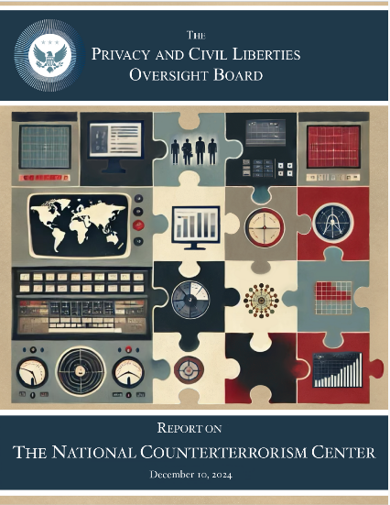
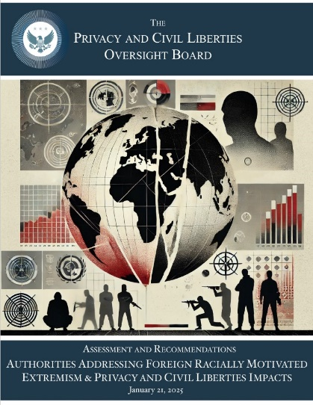
- Report on the National Counterterrorism Center. PCLOB released a report in December 2024 on the National Counterterrorism Center’s (NCTC) implementation of the 2012 Attorney General-approved guidelines designed to govern NCTC’s access to and handling of datasets containing non-terrorism information. The report assessed whether NCTC’s implementing policies and practices concerning such materials under the guidelines are consistent with governing laws, regulations, and policies and appropriately balance privacy and civil liberties interests with national security interests relating to counterterrorism. The report included recommendations to guide the Office of the Director of National Intelligence and NCTC as NCTC continues its efforts to apply the requirements of the guidelines and implementation procedures.
- Assessment and Recommendations: Authorities Addressing Foreign Racially Motivated Extremism and Privacy and Civil Liberties Impacts. In January 2025, PCLOB released a report that assessed the impacts on the privacy and civil liberties of U.S. persons concerning the use or recommended use of any federal laws, regulations, and policies to address significant threats to the United States and to U.S. persons associated with foreign racially motivated violent extremist organizations. The report, which included recommendations on options to develop protections to mitigate such impacts, was issued in response to Section 824 of the Consolidated Appropriations Act of 2022. PCLOB issued an addendum to this report in July 2025.

- Terrorist Watchlist. PCLOB released a report in January 2025 on the Terrorist Screening Dataset, commonly referred to as the Terrorist Watchlist. The report provided historical background of the Watchlist, described the government’s standards to nominate to and remove individuals from the Watchlist, and explained redress processes. The report included seven recommendations for program improvements to enhance privacy and civil liberties safeguards.
- Facial Recognition Technology in Aviation Security. PCLOB released a report in May 2025 evaluating the use of facial recognition technology (FRT) by the Transportation Security Administration (TSA). The report described the operations of FRT at domestic security checkpoints, discussed risks to privacy and civil liberties and how TSA addresses those risks, and made recommendations to further improve the program.
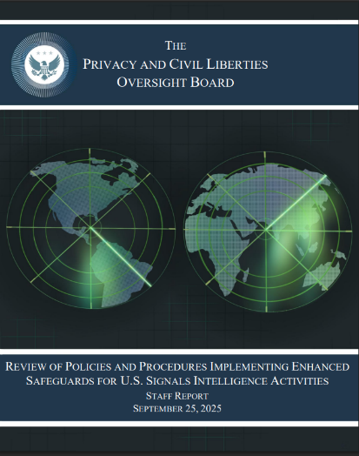
- Review of Policies and Procedures Implementing Enhanced Safeguards for U.S. Signals Intelligence Activities. In September 2025, PCLOB released a report in accordance with its commitment pursuant to EO 14086 on Enhancing Safeguards for United States Signals Intelligence Activities. Specifically, PCLOB reviewed implementation of the updated policies and procedures adopted by the Intelligence Community to ensure that they are consistent with the enhanced safeguards contained in the order. The report made two recommendations which the Intelligence Community will address within 180 days of PCLOB’s report. PCLOB intends to review the processing of qualifying complaints under the redress mechanism established by EO 14086 in a future report.

Additional Oversight Projects
- FBI Use of Open Source Information. PCLOB is reviewing the FBI’s acquisition and use of data from open source or commercially available sources as part of the FBI’s efforts to protect the nation against terrorism, as well as the legal, policy, and technological safeguards in place to protect privacy and civil liberties.
- Section 702 of the Foreign Intelligence Surveillance Act (FISA). PCLOB will provide an update to its 2023 FISA Section 702 report, focusing on recent changes to the program. The forthcoming report will discuss how the Intelligence Community has implemented changes directed under the Reforming Intelligence and Securing America Act of 2024 (RISAA), and how those changes have impacted the Intelligence Community’s compliance with the Section 702 procedures.
- Countering Domestic Terrorism. PCLOB is examining government policies and activities designed to counter domestic terrorism. This project has two simultaneous and distinct workstreams: 1) how the Government’s activities to counter domestic terrorism intersect with First Amendment rights; and 2) whether and how the Government’s efforts to counter domestic terrorism uniquely affect the privacy and civil liberties of particular groups.
- Tactical Terrorism Response Teams. PCLOB is reviewing the use of Tactical Terrorism Response Teams (TTRTs) by U.S. Customs and Border Protection. This review examines TTRT authorities, activities, and encounters at ports of entry and within the border zone, with particular focus on interactions between TTRTs and U.S. persons; information sharing between TTRTs and other government agencies; the effectiveness of TTRTs in countering terrorism; and whether the program appropriately safeguards privacy and civil liberties.
- Other Oversight Work. In addition, PCLOB continues to track technological developments through an artificial intelligence and machine learning working group (further described below), as well as an emerging technologies working group.

F
FY 2025 Performance Results: Strategic Goal 1
As depicted in the graphic below, PCLOB was tracking to meet eight of ten (or 80%) established performance indicators under this strategic goal by the end of FY 2025.
PCLOB’s results for two measures (#1.1.1 and #1.2.3) improved from off-track to on-track in FY 2025 because of the agency’s efforts to approve new projects and provide pertinent training to staff. However, two of the agency’s measures relating to recommendations assessment reports (#1.3.1 and #1.3.2) were deemed as off-track since the mission was focused on other workstreams in FY 2025.

STRATEGIC GOAL 2: ADVICE
Provide effective and timely advice to ensure that liberty concerns are appropriately considered in the development and implementation of laws, regulations, and policies related to efforts to protect the nation against terrorism.
Background
PCLOB advises the White House and other executive branch agencies to ensure that privacy and civil liberties protections are appropriately considered in programs and policies related to counterterrorism efforts.
FY 2025 Accomplishments
- Coordination of Executive Branch Privacy and Civil Liberties Activities Under Section 803. Section 803 of the Implementing Recommendations of the 9/11 Commission Act of 2007 requires agencies’ Civil Liberties and Privacy Officers (CLPOs) to issue reports, not less than annually, about their activities to their respective agency heads, Congress, and PCLOB. At a minimum, the reports must detail the following:
- Information on the number and types of reviews undertaken;
- The type of advice provided, and the response given to such advice;
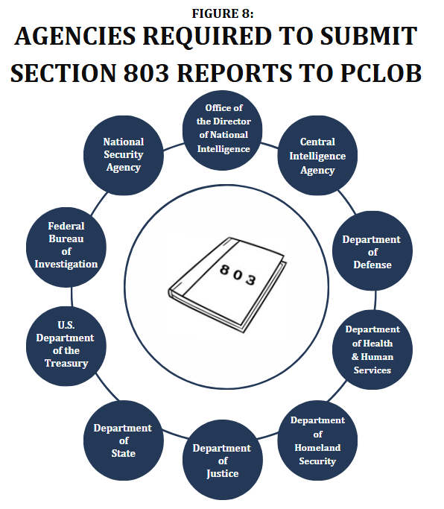
- The number and nature of the complaints received by the department, agency, or element concerned for alleged violations; and
- A summary of the disposition of such complaints, the reviews and inquiries conducted, and the impact of the activities of such officers.
In an effort to increase public access to and visibility of Section 803 reports, in FY 2023, PCLOB created a new page on the agency’s website entitled Section 803. This webpage provides convenient access to any reports PCLOB receives (see Figure 8, Agencies Required to Submit Section 803 Reports to PCLOB). In FY 2025, PCLOB received a total of five Section 803 reports (from Treasury, the Central Intelligence Agency, the Department of Homeland Security (DHS), the FBI, and the National Security Agency); these reports are accessible from the PCLOB website.
PCLOB is charged with assessing Section 803 reports and other information received from agency CLPOs, and where appropriate, making recommendations and coordinating the activities of Section 803 CLPOs. PCLOB continues to discuss with the Section 803 CLPOs ways in which the Section 803 reporting process can be improved. Recent efforts already undertaken include reminding agency CLPOs of their statutory obligation and requesting agency CLPOs to meet with PCLOB regularly to address the Section 803 reporting process. PCLOB intends, through improved coordination, to remedy any confusion regarding the Section 803 reporting process and encourage agency CLPOs to re-prioritize these reports.
FY 2025 Performance Results: Strategic Goal 2
As depicted in the graphic below, PCLOB was tracking to meet one of three (or 33%) established performance indicators under this strategic goal by the end of FY 2025.
The off-track measure related to providing advice (#2.2.1) stems from the need for further cooperation from other agencies; advice can be offered by PCLOB or requested by other agencies. Although PCLOB recently completed advice projects and did offer several advice projects in FY 2025 (resulting in an on-track measure for #2.1.1), no agencies agreed to receive that advice and thus, no advice projects were initiated. Similarly, PCLOB staff did not meet with Section 803 CLPOs despite several outreach efforts, resulting in a second off-track measure result (#2.3.1).

STRATEGIC GOAL 3: TECHNOLOGY
Strengthen PCLOB’s capabilities and knowledge regarding advanced and emerging technologies, their potential impacts on, and potential to safeguard, privacy and civil liberties, and their potential uses to perform oversight.
Background
Given the potential implications of new and developing technologies for privacy and civil liberties, their potential deployment should be accompanied by rigorous independent consideration of privacy and civil liberties concerns, considering the views of stakeholders inside and outside of government.
FY 2025 Accomplishments
Several of PCLOB’s oversight projects included a particular focus on the government’s use of emerging technologies:
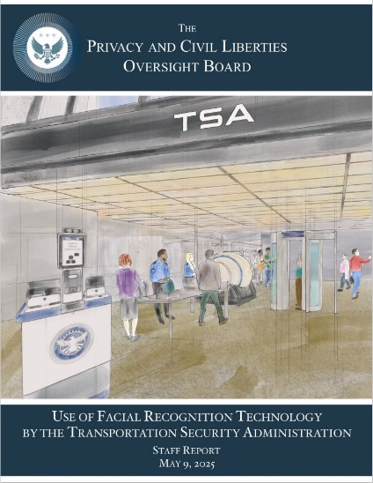
- Facial Recognition Technology in Aviation Security. As previously mentioned, PCLOB released a comprehensive staff report evaluating the TSA’s use of facial recognition technology for aviation security. The report reviews how facial recognition technology is used to verify the identity of passengers at airport security checkpoints, considering both operational benefits and privacy and civil liberties concerns; discusses risks to privacy and civil liberties and how TSA addresses those risks; and makes recommendations to further improve the program.
- Artificial Intelligence (AI) and Machine Learning. With the increased use of AI by national security agencies comes increased risks to privacy, civil rights, and civil liberties. PCLOB continued to track developments regarding advanced and emerging technologies through an AI and machine learning working group and is considering various areas for possible oversight and advice.

FY 2025 Performance Results: Strategic Goal 3
As depicted in the graphic below, PCLOB was tracking to meet all seven (or 100%) established performance indicators under this strategic goal by the end of FY 2025.
PCLOB met all of its strategic objectives relating to the privacy and civil liberties implications of using advanced and emerging technologies. As previously mentioned, PCLOB opened a new project on the Section 702 surveillance program early in the year and issued a staff report on TSA’s use of facial recognition technology in May 2025. Further, despite shifts in the agency’s staffing, PCLOB retained the desired technical expertise necessary to meet the other metrics relating to this strategic goal.

STRATEGIC GOAL 4: TRANSPARENCY
Further promote transparency regarding PCLOB activities and executive branch counterterrorism efforts that impact privacy and civil liberties to the greatest extent possible, consistent with the protection of classified information and applicable law.
Background
To achieve its goal of transparency, PCLOB has committed to ensuring that its work is available, relevant, and informative for the public, Congress, and other federal agencies. PCLOB’s statute requires it to hold public hearings and otherwise inform the public of its activities to the greatest extent (as depicted in Figure 9, How PCLOB Promotes Transparency) consistent with the protection of classified information and applicable law.
FY 2025 Accomplishments
- Board Member Testimonies/Briefings.
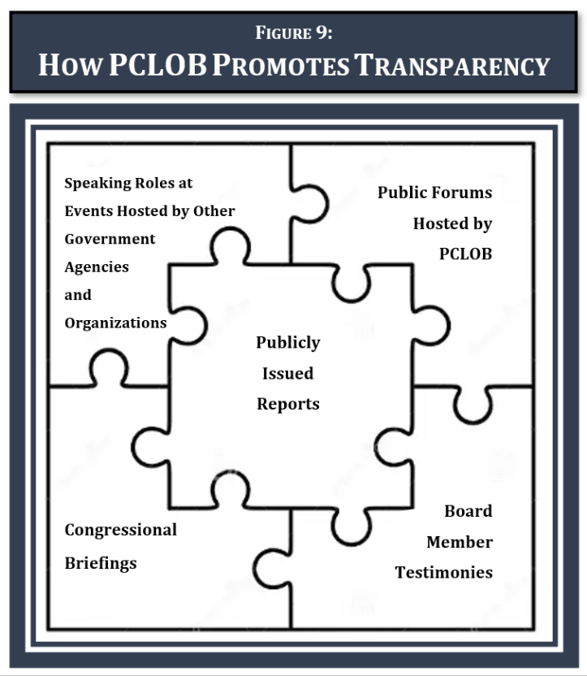
  - In March 2025, Member Williams met with Michael McGrath, the European Union (EU) Commissioner for Democracy, Justice, the Rule of Law and Consumer Protection, to discuss PCLOB’s role under EO 14086 in ensuring safeguards for cross-border data flows under the EU-U.S. Data Privacy Framework.
  - In April 2025, Member Williams met with Professor Dr. Louisa Specht-Riemenschneider, Germany’s Federal Commissioner for Data Protection and Freedom of Information. Among other things, they discussed PCLOB’s role under EO 14086 in ensuring safeguards for cross-border data flows under the EU-U.S. Data Privacy Framework.
  - Member Williams met with Representative Jay Obernolte (R-CA) in July 2025 to discuss the bipartisan AI Task Force, congressional priorities related to AI, and AI implications on national security.
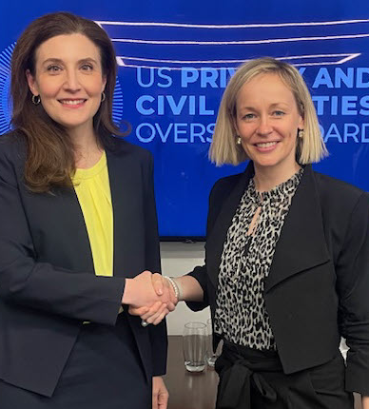
- Participation in Outside Events. Board Member involvement in events hosted by other government agencies and organizations included the following:
  - In February 2025, Member Williams delivered a keynote address about PCLOB’s mission, current projects, and path forward at the State of the Net Conference, hosted by the Internet Education Foundation.
  - In April 2025, Member Williams led a government-to-government meeting of international Data Protection Authorities as part of the International Association of Privacy Professionals’ annual Global Privacy Summit.
Above: Member Beth A. Williams met with Professor Dr. Louisa Specht-Riemenschneider, Germany’s Federal Commissioner for Data Protection and Freedom of Information on April 21, 2025. Photo credit: PCLOB/Alan Silverleib
- Staff Briefings/Engagements.
- In February 2025, PCLOB staff presented the findings of its Terrorist Watchlist report to Senate Homeland Security and Governmental Affairs Committee staff.
- In May 2025, PCLOB staff briefed staff from the office of Senator Jeff Merkley (D-OR) on the details of the agency’s Facial Recognition Technology report.
- In July 2025, PCLOB staff presented its FY 2026 Budget Justification to members of the Senate Appropriations Committee.
- In September 2025, PCLOB staff met with House Financial Services Committee staff to discuss debanking in the context of ongoing counterterrorism efforts.
- Publicly Issued Reports.
- In addition to various oversight and financial reports already referenced, PCLOB issued a Semi-Annual Report in June 2025, covering the agency’s activities for the period of July through December 2024.
FY 2025 Performance Results: Strategic Goal 4
As depicted in the graphic below, PCLOB was tracking to meet twelve of fourteen (or 86%) established performance indicators under this strategic goal by the end of FY 2025.
One of the metrics for this goal (#4.2.1), relating to the issuance of a second semi-annual report, could not be achieved with a sub-quorate Board. PCLOB also did not meet its goal of hosting a public forum in FY 2025 (#4.3.2). Overall, however, PCLOB successfully achieved most of its goals relating to transparency, as described in the various speaking events, meetings, and briefings above.

STRATEGIC GOAL 5: STRENGTH
Continue to enhance PCLOB’s institutional strength and capacity.
Background
The agency is staffed by Board Members and their respective counselors, mission staff (i.e., those professionals who work on agency oversight and advice projects), general counsel staff, a director of legislative and public affairs, and operations staff (i.e., those professionals who provide operational support in specialized areas). In a manner consistent with its small size and limited workforce, PCLOB must continuously work to achieve a standard of excellence in both mission and operational activities and meet the agency’s fifth strategic goal. The small operations staff (eight full-time employees as of the end of FY 2025) often work outside of their primary duties when necessary to accomplish operational responsibilities and support the mission. Operational responsibilities are divided into four key departments: human resources, financial management, information technology, and security.
FY 2025 Accomplishments
Human Resources and Workforce Management
- Efforts to Retain Qualified Staff.
- Continued Implementation of Recruitment and Retention Incentive Policy. A Board-approved recruitment and retention incentive policy continued to be used to retain employees deemed critical to the agency’s mission.
- PCLOB Enrichment Days. Staff came together for off-site team building and recognition events in a continued effort to boost employee morale.
- Efforts to Comply with Executive Orders and Enhance the Workforce. The agency’s small staff has diligently worked to track and comply with all executive orders, policies, and memoranda. During this process, PCLOB leadership and operations staff have analyzed and reviewed current procedures, and, as necessary, developed plans for implementation to align with the President’s agenda. Some significant areas of focus include, but are not limited to, agency staffing reorganization, hiring and probationary staff processing procedures, and performance management.
Financial Management

- Continued Implementation of G-Invoicing. Efforts to manage as many of its agreements with federal trading partners in G-invoicing, as mandated by Fiscal Service under the authority of 31 U.S.C. 3512(b) and 3513, continued into FY 2025 as more federal trading partners became G-Invoicing ready. PCLOB entered into more agreements in G-invoicing than before, allowing the agency to negotiate and accept General Terms and Conditions agreements, broker orders, exchange performance information, and validate settlement requests through Intra-Governmental Payment and Collection (IPAC). The agency looks forward to reaping the long-term benefits of G-Invoicing, which include better communication between trading partners; greater transparency to decrease differences between agencies; common data standards to reduce misunderstandings; agreed-upon processes to support timely and accurate accounting; and streamlined settlements of funds in IPAC for more timely and efficient settlements.
- Excellence in Reporting. In May 2025, PCLOB received its third CEAR award from the AGA. The AGA presents the esteemed CEAR award each year to federal agencies that produce high-quality Performance and Accountability Reports and AFRs.
- Maximized Efficiencies Through Contracted Services. PCLOB has compensated for its small size by using shared service providers for several key functions: financial, payroll and human resources, and procurement services. These shared service providers employ individuals who are experts in their field, entrusted to perform critical tasks reliably on a timely schedule. Contracting with shared service providers has enabled PCLOB to identify and resolve errors, leverage shared service provider’s software, and more confidently and more quickly stay up to date on regulations.
Above: Members of PCLOB accepted the 2024 CEAR Award at the May 2025 AGA CEAR Awards Ceremony. Photo credit: AGA
IT Systems and Cybersecurity
- Favorable FY 2025 Federal Information Security Modernization Act Results. Information security also continues to be a top priority for the agency. PCLOB’s FY 2025 Federal Information Security Modernization Act of 2014 (FISMA) audit concluded that its internal controls were effective in protecting information resources. PCLOB conducted multiple independent penetration assessments to evaluate the network security posture, validate the effectiveness of existing controls, and ensure continued alignment with the National Institute of Standards and Technology (NIST) and the Cybersecurity and Infrastructure Security Agency (CISA) cybersecurity requirements. The assessments detected no critical or high vulnerabilities across PCLOB’s network infrastructure.
- Continued Network Provision to Staff Without Incident. PCLOB’s IT staff remains focused on solidifying the agency’s cybersecurity posture while maintaining infrastructure and strategies to support a converged work environment. As a result of these efforts, PCLOB did not experience any major cybersecurity incidents in FY 2025.
- IT Compliance with Federal Standards.
  - PCLOB’s IT staff successfully responded to CISA Emergency Directive 25-03, Identify and Mitigate Potential Compromise of Cisco Devices, to identify and remediate at-risk agency devices.
  - PCLOB continues to strengthen its cybersecurity posture by leveraging shared services and contractor support to enhance boundary protection. IT staff implemented, maintained, and documented technical controls to comply with federal cybersecurity standards the objectives outlined in OMB M-24-14, Administration Cybersecurity Priorities for the FY 2026 Budget. These efforts advance the priority of defending critical infrastructure. PCLOB also continues to adopt and integrate tools and strategies that align with the principles of NIST Special Publication 800-207, Zero Trust Architecture to achieve a more resilient and adaptive security framework.
  - PCLOB maintained compliance with DHS Binding Operational Directive 22-01, Reducing the Significant Risk of Known Exploited Vulnerabilities to remediate vulnerabilities according to timelines outlined in the CISA managed catalog.
Security
PCLOB remains committed to protecting sensitive and classified materials. Ongoing efforts and achievements included:
- Maintenance of SCIF Accreditation. The highly sensitive information that the agency handles requires a secure area where classified information can be stored, discussed, and processed. The majority of PCLOB’s headquarters office space is in a SCIF, built to meet the strict security standards set by the Director of National Intelligence and subject to accreditation which includes continuous monitoring, periodic re-evaluations, and document reviews.

- Implementation of EO 13587, Structural Reforms to Improve the Security of Classified Networks and the Responsible Sharing and Safeguarding of Classified Information. PCLOB maintained its Insider Threat program in accordance with EO 13587 to deter, detect, and mitigate actions by insiders who represent a threat to national security.
- Vetting of PCLOB Workforce for Required Security Access. PCLOB continues to engage in government-wide efforts to modernize the security clearance process. This includes continued implementation of Trusted Workforce (TW) 2.0. and National Security Presidential Memorandum 28, which directs agencies to implement an Operations Security program. PCLOB also continues its efforts to ensure Controlled Unclassified Information received from partner agencies is protected.

FY 2025 Performance Results: Strategic Goal 5
As depicted in the graphic below, PCLOB was tracking to meet 15 of 23 (or 65%) established performance indicators under this strategic goal by the end of FY 2025.
PCLOB developed a comprehensive list of performance measures concerning institutional strength because a stronger and more capable agency enhances the potential for achieving its mission. The agency successfully met targets for the majority of the measures; of note, the agency enhanced its tracking of training, expanded the range of professional development opportunities available, and exceeded its reponse targets related to Freedom of Information Act requests.
While some unmet metrics indicated areas for continued development and growth, some metrics could not be achieved due to constraints outside of PCLOB’s control. For example, the Board’s sub-quorum status limited policy updates in FY 2025 since formal agency policies can only be formulated or implemented by a quorate Board. Further, the agency lost its equal employment opportunity director in early FY 2025, resulting in some missed reporting requirements. Other metrics that were not met (e.g., several relating to completion rates of required staff training) highlight areas for improvement in FY 2026.

Significant Opportunities and Risks


Opportunities
Photo credit: f11photo via Adobe Stock
PCLOB continues its work to achieve the goals, objectives, and strategies outlined in the agency’s FY 2022–2026 Strategic Plan. In FY 2026, PCLOB plans to initiate the following activities:
- Review of Oversight and Advice Projects. PCLOB has been actively working on mission projects that have been on the agency’s docket for many years, with a focus toward expedient completion. As a result of these efforts, several projects are expected to be completed in FY 2026. The agency’s Executive Director is also working with staff to develop proposals for areas of additional federal oversight to enable the Board (when restored to a quorum) to assess what new oversight and advice projects to initiate.

- Continued Exercise of Roles Under EO 14086, Enhancing Safeguards for United States Signals Intelligence Activities. PCLOB will continue to conduct annual reviews (to the extent feasible) of the redress process pursuant to EO 14086. This annual review represents a new and innovative role for PCLOB, and the U.S. Government has highlighted the value of PCLOB’s oversight.
- Countering Domestic Terrorism. PCLOB will continue its investigation into the government’s domestic counterterrorism efforts. This involves ongoing information gathering from DHS and FBI regarding their domestic terrorism authorities and operations. PCLOB intends to assess whether additional privacy and civil liberties safeguards are necessary in these areas.
- Section 702. With Section 702 up for reauthorization in April 2026, PCLOB will continue its work to provide an update to PCLOB’s 2023 Section 702 Report, focusing on the major changes made in RISAA, how agencies have implemented those changes, and the resulting impact on privacy and civil liberties and national security.
- AI and Machine Learning. PCLOB will continue tracking the government’s use of AI and machine learning in counterterrorism efforts and look for opportunities to provide privacy and civil liberties advice as intelligence agencies adopt the technology.
- Increased Staff Development. PCLOB will further engage in staff development. PCLOB will continue to hold monthly knowledge sessions for agency staff to learn new subject areas, skills, and investigative processes and tools. Additional opportunities the agency will offer to staff include federal privacy training programs, technical certifications, mentorship initiatives, and standardized practice guidelines.
- Continued Outreach to the Public, Congress, and Other Federal Agencies. PCLOB will maintain its practice of hosting public forums to collect information for its ongoing oversight reviews, to consider future oversight projects, and to communicate its findings to the public. Additionally, PCLOB will convene regular meetings with privacy officers from the agencies it oversees and will actively participate in the Federal Privacy Council and privacy groups established by the White House.
- Continued Implementation of PCLOB’s New Performance Framework. PCLOB will continue efforts to refine the framework by identifying and addressing any off-track measures, redefining baseline targets as needed, and providing regular status updates to both program managers and to the Board.

Risks
RE-ESTABLISHING A BOARD QUORUM
As previously mentioned, each of the five Members of the Board is appointed by the President and with the advice and consent of the Senate. PCLOB’s statute requires that Members of the Board be selected based on their professional qualifications, achievements, public stature, expertise in civil liberties and privacy, and other relevant experience; no more than three Members of the Board may come from the same political party. As a result of this process, vacant Member seats can take time to fill.
In October 2024, the quorate Board adopted a new sub-quorum policy to ensure that various mission-related activities and administrative support functions could continue more fully than in previous sub-quorum periods. When the Board went sub-quorum in early 2025, significant and substantive work continued under the direction of the remaining Member. While additional projects can be pursued in the name of the individual Member, a quorum is required to open new PCLOB projects.
ACHIEVING COMPLIANCE DESPITE SIZE LIMITATIONS
As a small, executive branch agency, consisting of fewer than 30 full-time employees at the end of FY 2025, PCLOB must still meet various statutory requirements applicable to all agencies. Compliance can pose challenges given PCLOB’s limited staff and resources, as well as its unique mission which often requires handling classified information. To that end, as provided in OMB Circular A-11, Preparation, Submission, and Execution of the Budget, PCLOB sought and obtained from OMB a five-year exemption from certain sections of GPRA. As long as PCLOB’s annual outlays remain under $20 million, the agency remains exempt from annual performance plan and performance reporting requirements until FY 2030. However, the agency will continue to report on its performance through its mission projects and operational achievements in the reports issued throughout the year such as the semi-annual reports, congressional budget justifications, and AFRs.

FY 2025 Management Assurance Statement
The management of PCLOB is responsible for establishing and maintaining effective internal control over financial reporting, which includes safeguarding of assets and compliance with applicable laws and regulations, in accordance with the objectives of the Federal Managers’ Financial Integrity Act of 1982 (FMFIA).
We conducted our assessment of the effectiveness of the PCLOB’s internal control over financial reporting in accordance with OMB Circular A-123, Management’s Responsibility for Internal Control. Based on the results of this evaluation, PCLOB can provide reasonable assurance that internal control over financial reporting as of September 30, 2025, was operating effectively and no material weaknesses were found in the design or operation of the internal controls over financial reporting.

Beth A. Williams Raheel Baig
Board Member Deputy Executive Director for Operations
November 14, 2025 November 14, 2025


Analysis of Systems, Controls, and Legal Compliance
Photo credit: Sarbinaz Mustafina via Adobe Stock
This section presents the financial management system framework and strategy; addresses PCLOB’s compliance with FMFIA and other applicable laws; and provides the required management assurance statements, including addressing any key internal control issues.
Federal Managers’ Financial Integrity Act of 1982
FMFIA mandates that agencies establish effective internal control to provide reasonable assurance that (1) obligations and costs are in compliance with applicable law; (2) funds, property, and other assets are safeguarded against waste, loss, unauthorized use, or misappropriation; and (3) revenues and expenditures applicable to agency operations are properly recorded and accounted for to permit the preparation of accounts and reliable financial and statistical reports and to maintain accountability over the assets.
FMFIA requires agencies to establish accounting and administrative controls over program, operational, and administrative functions, in addition to accounting and financial management. FMFIA also requires standards to ensure the prompt resolution of all audit findings and mandates for agency heads to annually evaluate agency controls and provide an assurance statement on the adequacy of internal and administrative controls (Section 2) and conformance of systems with government-wide standards (Section 4).
The FMFIA FY 2025 Management Assurance Statement, included earlier in this section, is consistent with the FY 2025 financial statement audit report, included in the Financial Section of this report.
PCLOB depends on the integrity of ARC’s systems to provide reliable data. ARC, in turn, places a high level of emphasis on maintaining adequate management controls and is responsible for meeting the objectives of Section 2 and Section 4 of FMFIA and the Reports Consolidation Act of 2000. ARC annually evaluates both its management controls and information systems. Periodic audits of the mainframe system and annual issuance of Statement on Standards for Attestation Engagements Service Organization Control Type II reports are regularly performed by an independent auditor under contract with ARC to ensure the management controls systems and financial management systems are in overall compliance with prescribed standards.
Enterprise Risk Management, Internal Controls System, and Implementation of the Federal Managers’ Financial Integrity Act
FMFIA provides that GAO establish internal control standards, which are contained in GAO’s Standards for Internal Control in the Federal Government. FMFIA also provides that OMB establish the implementation requirements for the assessment and annual reporting on internal controls, which are included in Circular A-123, Management’s Responsibility for Enterprise Risk Management and Internal Control. The GAO standards and OMB’s implementation requirements work in tandem to guide PCLOB’s internal control program required by FMFIA.
The agency’s Internal Controls Framework (ICF) Manual was issued in 2019 and updated in April 2023 with the goal of ensuring sound financial and non-financial risk management while accounting for PCLOB’s small size and limited resources. The ICF Manual sets out the agency’s oversight role and strategic decision-making over enterprise risk management and policies and procedures for establishing, assessing, correcting, and reporting on internal control.
To ensure the agency continues to maintain a robust internal control framework and meet the guidelines established in the ICF Manual despite its small size, PCLOB outsources with an independent contractor to provide internal controls support services, such as risk assessment, testing, and remediation, with oversight from the CFO.

In FY 2025, the Internal Controls Team conducted a comprehensive risk assessment to identify agency risks and rate the likelihood and impact of each risk. The Internal Controls Team also updated key controls to address risks and assessed the design and operating effectiveness of these controls through detailed test procedures over all financial processes. No deficiencies were identified, and PCLOB’s internal controls were found to be operating effectively.
Photo credit: Orhan Cam via Adobe Stock
Other Compliance with Laws and Regulations
- Federal Information Security Modernization Act
FISMA requires federal agencies to “develop, document, and implement an agency-wide information security program to provide information security for the information and information systems that support the operations and assets of the agency, including those provided or managed by another agency, contractor, or other source.” In addition, FISMA requires federal agencies to conduct annual assessments of their information security and privacy programs, to develop and implement remediation efforts for identified weaknesses and vulnerabilities, and to report compliance to OMB. PCLOB’s Office of the Chief Information Officer performs a review of the agency’s compliance with FISMA requirements each year. Due to the lapse in appropriations beginning October 1, 2025, OMB delayed submission of agency FY 2025 metrics and Senior Agency Official for Privacy FISMA reports until Congress appropriates funding for FY 2026.
- Payment Integrity Information Act of 2019
The Payment Integrity Information Act (PIIA) of 2019 requires agencies to assess and identify high-risk programs and activities and report findings in the AFR. See the Payment Integrity Information Act of 2019 section included in the “Other Information” section of the AFR for further information on PCLOB’s compliance with PIIA.
- Prompt Payment Act
The Prompt Payment Act requires federal agencies to report on their efforts to make timely payments to vendors, as well as the amount of interest penalties paid for late payments. ARC prepares prompt pay, discounts lost, and improper payment metrics for PCLOB (on a monthly basis for PCLOB’s internal review and on a quarterly basis to Connect.gov) and performs monthly audits to provide assurance that the Invoice Processing Platform (IPP) system controls are operating as intended. In FY 2025, PCLOB had zero improper payments.
- Debt Collection Improvement Act
PCLOB does not currently manage debt but continues to monitor provisions of the Debt Collection Improvement Act of 1996; OMB Circular A-129, Policies for Federal Credit Programs and Non-Tax Receivables; and other relevant laws to ensure compliance.
- Digital Accountability and Transparency Act
The Digital Accountability and Transparency Act of 2014, or DATA Act, was signed into law in May 2014 to establish governmentwide financial data standards and increase the availability, accuracy, and usefulness of federal spending information. DATA Act implementation, led by Treasury and OMB, requires federal agencies to report on procurement data to bring awareness to federal spending. Pursuant to the statutory reporting requirements, federal spending that is reported on usaspending.gov is derived from financial and contract award information. The agency’s financial system is updated with the most recent version of Governmentwide Spending Data Model, formally known as the DATA Act Information Model Schema, to ensure that the submission of all required financial data elements is complete and accurate. As for contract award data, the agency uses ARC’s procurement system, PRISM, for domestic contracts, which automatically updates to Federal Procurement Data System-Next Generation, the central repository of information for federal contracting. Validation issues between financial and award information are reconciled each month to ensure that spending data is accurate.
ARC’s services strengthen PCLOB’s ability to reach full DATA Act compliance. Services which improve the quality and transparency of federal spending data include:
- Financial Reporting. ARC assists PCLOB in preparing and submitting financial and payment information as required by the DATA Act while ensuring data accuracy and completeness;
- Data Transparency. To enhance data transparency, ARC provides tools and resources for better data management and reporting;
- Compliance Support. ARC offers guidance on compliance and best practices to help PCLOB meet DATA Act reporting requirements;
- System Integration. ARC integrates financial management systems to streamline data collection and reporting processes, making it easier for PCLOB to comply with DATA Act requirements; and
- Training and Resources. ARC provides DATA Act training and resources to help PCLOB understand and implement requirements effectively.

Other Systems and Control Considerations
- Financial Management Systems Strategy
PCLOB strives to maintain and enhance financial management systems, processes, and controls that ensure accountability and transparency, provide data and information to decision makers, and comply with federal laws, regulations, and policy. As a very small agency with limited resources and a staff much smaller than most federal agencies, PCLOB must turn to shared-service providers to achieve these goals to assist the agency’s full-time operational staff with critical functions such as human resources and payroll, financial management, and procurement.

The decision to use shared-service arrangements directly correlates with the agency’s strategic goal and objectives relating to institutional strength and capacity and, thus far, has been a good one. Since transitioning to ARC (for financial management and procurement services) and DOI’s Interior Business Center, or IBC (for human resources and payroll services), PCLOB has experienced improved customer service with real-time access to highly reliable financial data, managed by experts in their functional area. Further, the benefits achieved with access to the technological systems provided through ARC and IBC have been significant. Oracle, widely used in the federal government and the agency’s system of record provided through ARC, is integrated with various end-user applications to capture the agency’s financial transactions. ARC also provides ready access to a whole host of other systems, to include Concur (a web-based system for travel and expense reimbursement), and PRISM, as well as various means of assessable support for each system when necessary.
Photo credit: rrodrickbeiler via Adobe Stock


- Anti-Deficiency Act
Photo credit: Stephen via Adobe Stock
The Anti-Deficiency Act comprises several statutes (see 31 U.S.C. §§ 1341, 1342, 1350, and 1511–1519) that mandate administrative and criminal sanctions for the unlawful use of appropriated funds (e.g., expending or authorizing an obligation or expenditure of federal funds in excess of an appropriation; incurring an obligation in advance of an appropriation, unless authorized by law; accepting voluntary services). The agency’s financial system is designed to prevent Anti-Deficiency Act violations through the implementation of a zero-tolerance funds control check at the fund and office level. This systematic control ensures that obligations are not recorded until monies are authorized and allotted by the Office of the Chief Financial Officer (OCFO). Further, OCFO regularly attends, and periodically provides to all staff, training sessions to ensure they understand the requirements of the Anti-Deficiency Act and other relevant financial regulations. These programs often include workshops, seminars, and online courses.

Financial Section

Financial Section

Message from the Chief Financial Officer
On behalf of the dedicated staff of PCLOB, it is my honor to present the Fiscal Year 2025 AFR. This document not only provides a transparent account of our financial position but also illustrates our unwavering commitment to sound management and operational excellence. My consolidated leadership responsibilities as CFO, PIO, and Deputy Executive Director for Operations provide a unique perspective on this commitment. This integrated role is crucial for maximizing PCLOB’s effectiveness as a small, independent oversight agency.
In my capacity as CFO, I am the ultimate steward of the public funds entrusted to PCLOB. In FY 2025, we once again achieved an unmodified, or “clean,” audit opinion, reflecting our meticulous approach to financial reporting and internal controls. Our team’s diligence in budget formulation, execution, and monitoring ensures that every dollar is used to advance our core mission of balancing counterterrorism efforts with the protection of privacy and civil liberties. This fiscal prudence is fundamental to demonstrating our accountability to Congress and the American public.
This financial accountability is seamlessly integrated with my function as the PIO. In FY 2025, we continued to mature the agency’s performance framework, tying financial resources directly to PCLOB’s strategic goals and operational priorities. We have focused on key areas, including enhancing our review processes for executive branch counterterrorism policies and refining our public reporting on privacy and civil liberties issues. By leveraging performance data, we make more informed decisions about resource allocation, ensuring that PCLOB’s work is not only financially sound but also strategically effective. This integrated view allows me to assess how our budget supports performance outcomes, leading to a more efficient and impactful organization.
As Deputy Executive Director for Operations, my focus is on the people and processes that power PCLOB’s mission. In FY 2025, we continued our emphasis on strengthening institutional capacity, from further developing our highly skilled workforce to refining our internal policies and governance. In a complex operational environment, particularly as our agency navigates issues related to classified information, emerging technologies, and a changing policy landscape, ensuring robust, efficient, and well-supported operations is paramount. My operational oversight ensures that our staff have the resources and support needed to deliver on PCLOB’s critical oversight and advisory functions.
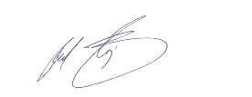
The combination of these roles creates a synergy that is vital for an agency of our size. It allows for a holistic view of PCLOB, where financial strategy, performance management, and operational leadership are not siloed but are deeply interconnected. This structure enables us to respond with agility to new challenges while maintaining the highest standards of financial integrity and operational efficiency. I am deeply grateful for the commitment of the entire PCLOB staff, whose hard work and dedication make these achievements possible.

Raheel Baig
Deputy Executive Director for Operations and Chief Financial Officer
November 14, 2025

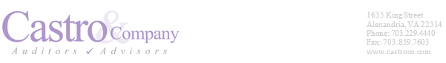
Independent Auditor’s Report

Independent Auditor’s Report
To the Members of the Board of the Privacy and Civil Liberties Oversight Board
Report on the Audit of the Financial Statements
Opinion
In accordance with the Accountability of Tax Dollars Act of 2002, we have audited the Privacy and Civil Liberties Oversight Board (PCLOB) financial statements, which comprise the balance sheet as of September 30, 2025, and the related statements of net cost, changes in net position, and budgetary resources for the fiscal year then ended, and the related notes to the financial statements.
In our opinion, PCLOB’s financial statements present fairly, in all material respects, PCLOB’s financial position as of September 30, 2025, and its net cost of operations, changes in net position, and budgetary resources for the fiscal year then ended in accordance with U.S. generally accepted accounting principles.
Basis for Opinion
We conducted our audit in accordance with U.S. generally accepted government auditing standards and guidance contained in Office of Management and Budget (OMB) Bulletin 24-02, Audit Requirements for Federal Financial Statements. Our responsibilities under those standards and OMB Bulletin 24-02 are further described in the Auditor’s Responsibilities for the Audit of the Financial Statements subsection of our report. We are required to be independent of the PCLOB and to meet our other ethical responsibilities, in accordance with the relevant ethical requirements relating to our audit. We believe that the audit evidence we have obtained is sufficient and appropriate to provide a basis for our audit opinion.
Responsibilities of Management for the Financial Statements
PCLOB Management is responsible for the (1) preparation and fair presentation of the financial statements in accordance with U.S. generally accepted accounting principles; (2) preparation, measurement, and presentation of the Required Supplementary Information (RSI) in accordance with U.S. generally accepted accounting principles; (3) preparation and presentation of other information included in PCLOB’s Agency Financial Report (AFR), and ensuring the consistency of that information with the audited financial statements and RSI; and (4) design, implementation, and maintenance of effective internal control relevant to the preparation and fair presentation of financial statements that are free from material misstatement, whether due to fraud or error.
Auditor’s Responsibility for the Audit of the Financial Statements
Our objectives are to (1) obtain reasonable assurance about whether the financial statements as a whole are free from material misstatement, whether due to fraud or error, and (2) issue an auditor’s report that includes our opinion. Reasonable assurance is a high level of assurance but is not absolute assurance and therefore is not a guarantee that an audit of the financial statements conducted in
Independent Auditor’s Report
Page 2

accordance with U.S. generally accepted government auditing standards and OMB guidance will always detect a material misstatement or a material weakness when it exists. The risk of not detecting a material misstatement resulting from fraud is higher than for one resulting from error, as fraud may involve collusion, forgery, intentional omissions, misrepresentations, or the override of internal control. Misstatements, including omissions, are considered to be material if there is a substantial likelihood that, individually or in the aggregate, they would influence the judgment made by a reasonable user based on the financial statements.
In performing an audit of financial statements in accordance with U.S. generally accepted government auditing standards and OMB guidance, we:
      - Exercise professional judgment and maintain professional skepticism throughout the audit.
- Identify and assess the risks of material misstatement of the financial statements, whether due to fraud or error, and design and perform audit procedures responsive to those risks. Such procedures include examining, on a test basis, evidence regarding the amounts and disclosures in the financial statements.
- Obtain an understanding of internal control relevant to our audit of the financial statements in order to design audit procedures that are appropriate in the circumstances but not for the purpose of expressing an opinion on the effectiveness of PCLOB’s internal control over financial reporting. Accordingly, no such opinion is expressed.
- Evaluate the appropriateness of accounting policies used and the reasonableness of significant accounting estimates made by management, as well as evaluate the overall presentation of the financial statements.
- Perform other procedures we consider necessary in the circumstances.
We are required to communicate with those charged with governance regarding, among other matters, the planned scope and timing of the audit, significant audit findings, and certain internal control–related matters that we identified during the financial statement audit.
Required Supplementary Information
U.S. generally accepted accounting principles issued by the Federal Accounting Standards Advisory Board (FASAB) require that the RSI be presented to supplement the financial statements. Such information is the responsibility of management and, although not part of the financial statements, is required by under standards issued by FASAB, which considers it to be an essential part of financial reporting for placing the financial statements in appropriate operational, economic, or historical context.
We have applied certain limited procedures to the RSI in accordance with U.S. generally accepted government auditing standards, which consisted of (1) inquiries of management about the methods used to prepare the RSI and (2) comparing the RSI for consistency with management’s responses to our inquiries, the financial statements, and other knowledge we obtained during the audit of the financial statements, in order to report omissions or material departures from FASAB guidelines, if
Independent Auditor’s Report
Page 3
any, identified by these limited procedures. We did not audit and we do not express an opinion or provide any assurance on the RSI because the limited procedures we applied do not provide sufficient evidence to express an opinion or provide any assurance.
Other Information
PCLOB’s other information contains a wide range of information, some of which is not directly related to the financial statements. This information is presented for purposes of additional analysis and is not a required part of the financial statements or RSI. Management is responsible for the other information included in the PCLOB’s AFR. The other information comprises the Messages from the Agency Head and Chief Financial Officer, and Other Information, and Appendices. Other information does not include the financial statements and our auditor’s report thereon. Our opinion on the financial statements does not cover the other information, and we do not express an opinion or any form of assurance thereon.
In connection with our audit of the financial statements, our responsibility is to read the other information and consider whether a material inconsistency exists between the other information and the financial statements, or the other information otherwise appears to be materially misstated. If, based on the work performed, we conclude that an uncorrected material misstatement of the other information exists, we are required to describe it in our report.
Other Reporting Required by Government Auditing Standards
Report on Internal Control over Financial Reporting
In connection with our audit of PCLOB’s financial statements, we considered PCLOB’s internal control over financial reporting, consistent with our auditor’s responsibilities discussed below.
Results of Our Consideration of Internal Control Over Financial Reporting
Our consideration of internal control was for the limited purpose described below and was not designed to identify all deficiencies in internal control that might be material weaknesses or significant deficiencies or to express an opinion on the effectiveness of PCLOB’s internal control over financial reporting. Given these limitations, during our Fiscal Year 2025 audit, we did not identify any deficiencies in internal control over financial reporting that we consider to be material weaknesses. However, material weakness or significant deficiencies may exist that have not been identified.
Basis for Results of Our Consideration of Internal Control over Financial Reporting
We performed our procedures related to PCLOB’s internal control over financial reporting in accordance with U.S. generally accepted government auditing standards and OMB audit guidance.
Responsibilities of Management for Internal Control over Financial Reporting
PCLOB management is responsible for designing, implementing, and maintaining effective internal control over financial reporting relevant to the preparation and fair presentation of financial statements that are free from material misstatement, whether due to fraud or error.
Independent Auditor’s Report
Page 4
Auditor’s Responsibilities for the Consideration of Internal Control over Financial Reporting
In planning and performing our audit of PCLOB’s financial statements as of and for the fiscal year ended September 30, 2025, in accordance with U.S. generally accepted government auditing standards, we considered PCLOB’s internal control relevant to the financial statement audit in order to design audit
procedures that are appropriate under the circumstances, but not for the purpose of expressing an opinion on the effectiveness of PCLOB’s internal control over financial reporting. Accordingly, we do not express an opinion on PCLOB’s internal control over financial reporting. We are required to report all deficiencies that are considered to be significant deficiencies or material weaknesses. We did not consider all internal controls relevant to operating objectives, such as those controls relevant to preparing performance information and ensuring efficient operations.
Definition and Inherent Limitations of Internal Control over Financial Reporting
An entity’s internal control over financial reporting is a process effected by those charged with governance, management, and other personnel. The objectives of internal control over financial reporting are to provide reasonable assurance that (1) transactions are properly recorded, processed, and summarized to permit the preparation of financial statements in accordance with U.S. generally accepted accounting principles, and assets are safeguarded against loss from unauthorized acquisition, use, or disposition, and (2) transactions are executed in accordance with provisions of applicable laws, including those governing the use of budget authority, regulations, and contracts, noncompliance with which could have a material effect on the financial statements.
Because of its inherent limitations, internal control over financial reporting may not prevent, or detect and correct, misstatements due to fraud or error.
Intended Purpose of Report on Internal Control over Financial Reporting
The purpose of this report is solely to describe the scope of our consideration of PCLOB’s internal control over financial reporting and the results of our procedures, and not to provide an opinion on the effectiveness of PCLOB’s internal control over financial reporting. This report is an integral part of an audit performed in accordance with U.S. generally accepted government auditing standards in considering internal control over financial reporting. Accordingly, this report on internal control over financial reporting is not suitable for any other purpose.

Report on Compliance and Other Matters

In connection with our audits of PCLOB’s financial statements, we tested compliance with selected provisions of applicable laws, regulations, and contracts consistent with our auditor’s responsibilities discussed below.

Independent Auditor’s Report
Page 5
Results of Our Tests for Compliance with Laws, Regulations, and Contracts
Our tests for compliance with selected provisions of applicable laws, regulations, and contracts disclosed no instances of noncompliance for Fiscal Year 2025 that would be reportable under U.S. generally accepted government auditing standards. However, the objective of our tests was not to provide an opinion on compliance with laws, regulations, and contracts applicable to PCLOB. Accordingly, we do not express such an opinion.
Basis for Results of Our Tests for Compliance with Laws, Regulations, and Contracts
We performed our tests of compliance in accordance with U.S. generally accepted government auditing standards.
Responsibilities of Management for Compliance with Laws, Regulations, and Contracts
PCLOB management is responsible for complying with laws, regulations, and contracts applicable to the PCLOB.
Auditor’s Responsibilities for Tests of Compliance with Laws, Regulations, and Contracts
Our responsibility is to test compliance with selected provisions of laws, regulations, and contracts applicable to PCLOB that have a direct effect on the determination of material amounts and disclosures in PCLOB’s financial statements, and to perform certain other limited procedures. Accordingly, we did not test compliance with all laws, regulations, and contracts applicable to PCLOB. We caution that noncompliance may occur and not be detected by these tests.
Intended Purpose of Report on Compliance with Laws, Regulations, and Contracts
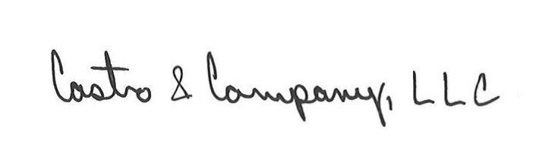
The purpose of this report is solely to describe the scope of our testing of compliance with selected provisions of applicable laws, regulations, and contracts, and the results of that testing, and not to provide an opinion on compliance. This report is an integral part of an audit performed in accordance with U.S. generally accepted government auditing standards in considering compliance. Accordingly, this report on compliance with laws, regulations, and contracts is not suitable for any other purpose.

Alexandria, VA
November 14, 2025

Audited Financial Statements
The accompanying notes are an integral part of these financial statements.

The accompanying notes are an integral part of these financial statements.

The accompanying notes are an integral part of these financial statements.

The accompanying notes are an integral part of these financial statements.


Notes to the Financial Statements

NOTE 1 Summary of Significant Accounting Policies
NOTE 2 Fund Balance with Treasury
NOTE 3 Property, Plant, and Equipment, Net
NOTE 4 Liabilities Not Covered By Budgetary Resources
NOTE 5 Other Liabilities
NOTE 6 Leases
NOTE 7 Inter-Entity Costs
NOTE 8 Unobligated Balance from Prior Year Budget Authority, Net
NOTE 9 Undelivered Orders at the End of the Period
NOTE 10 Explanation of Differences Between the Statement of Budgetary Resources and the Budget of the U.S. Government
NOTE 11 Reconciliation of Net Cost to Budgetary Net Outlays

NOTE 1 — SUMMARY OF SIGNIFICANT ACCOUNTING POLICIES
A. Reporting Entity
PCLOB was established as an independent agency within the executive branch under its enabling statute, 42 U.S.C. § 2000ee. The reporting entity is comprised of a general fund (funds not earmarked by law for a specific purpose), operating as a single entity under a single program.
PCLOB is a component of the U.S. Government. For this reason, some of the assets and liabilities reported by the entity may be eliminated for government-wide reporting because they are offset by assets and liabilities of another U.S. Government entity. These financial statements should be read with the realization that they are for a component of the U.S. Government.
B. Basis of Presentation
The financial statements have been prepared to report on the financial position and results of operations of PCLOB. The Balance Sheet presents the financial position of the agency. The Statement of Net Cost presents the agency’s operating results. The Statement of Changes in Net Position displays the changes in the agency’s equity accounts. The Statement of Budgetary Resources presents the sources, status, and uses of the agency’s resources and follows the rules for the budget of the U.S. Government.
These financial statements are a requirement of the Accountability of Tax Dollars Act and have been prepared from, and are fully supported by, the records of PCLOB in accordance with U.S. GAAP and accounting standards issued by FASAB in the format prescribed by OMB A-136, Financial Reporting Requirements, as amended. FASAB is recognized by the AICPA as the authoritative accounting standards-setting body for U.S. Government entities. These statements, apart from the Statement of Budgetary Resources, are different from financial management reports, which are also prepared pursuant to OMB directives that are used to monitor and control PCLOB’s use of budgetary resources. Unless specified otherwise, all amounts are presented in dollars.
The financial statements represent intragovernmental and other than intragovernmental (or public) activities. The intragovernmental balances, revenues, and costs reflect financial transactions between PCLOB and other federal agencies, while other than intragovernmental activities are those with non-governmental customers, including employees, contractors, and vendors. PCLOB’s financial statements reflect agency-only financial activities and do not require consolidation.
C. Accounting Policies
Accounting principles encompass both accrual and budgetary transactions. Under the accrual method, revenues are recognized when earned and expenses are recognized when a liability is incurred, without regard to receipt or payment of cash. Under the budgetary basis, fund availability is recorded based upon legal considerations and constraints. The agency receives financing sources through direct appropriations from the general fund of the Treasury to support its operations. “Appropriations Used” recognizes that appropriation authority has been applied against received goods and services.
D. Use of Estimates
The preparation of financial statements in conformity with U.S. GAAP requires management to make certain estimates and assumptions. These estimates and assumptions affect the reported amounts of assets, liabilities (including contingent liabilities), revenues, financing sources, expenses, and obligations incurred during the reporting period. These estimates are based on management’s best knowledge of current events, historical experience, and other assumptions that are believed to be reasonable under the circumstances. Estimates are subject to a wide range of variables, including assumptions on future economic and financial events. Accordingly, actual results may differ from those estimates.
E. Budgetary Terms
PCLOB follows standard federal budgetary accounting policies and practices in accordance with OMB Circular A-11, Preparation, Submission, and Execution of the Budget, as amended, which provides instructions on budget execution. The purpose of federal budgetary accounting is to control, monitor, and report on funds made available to federal agencies by law and help ensure compliance with the law.
The following budget terms are commonly used:
- Appropriation — A provision of law (not necessarily in an appropriations act) authorizing the expenditure of funds for a given purpose. Usually, but not always, an appropriation provides budget authority.
- Budgetary Resources — Amounts available to incur obligations in a given year. The term comprises new budget authority and unobligated balances of budget authority provided in previous years.
- Obligation — A binding agreement that will result in outlays, immediately or in the future. Budgetary resources must be available before obligations can be legally incurred.
- Unobligated Balance — The cumulative amount of budget authority that remains available for obligation under law in unexpired accounts. The term “expired balances available for adjustment only” refers to unobligated amounts in expired accounts.
- Net Outlays — Outlays are payments to liquidate obligations (other than the repayment of debt principal or other disbursements that are “means of financing” transactions). Outlays generally are equal to cash disbursements but also are recorded for cash-equivalent transactions, such as the issuance of debentures to pay insurance claims, and, in a few cases, are recorded on an accrual basis such as interest on public issues of the public debt. Outlays are a primary measure of government spending. Net outlays represent gross outlays less actual offsetting collections.
- Offsetting Collections — Usually, offsetting collections are authorized to be spent for the purposes of the account without further action by Congress. They usually result from business-like transactions with the public, including payments from the public in exchange for goods and services, reimbursements for damages, and gifts or donations of money to the Government and from intragovernmental transactions with other Government accounts. The authority to spend offsetting collections is a form of budget authority.
- Spending Authority from Offsetting Collections — A type of budget authority that permits obligations and outlays to be financed by offsetting collections.
Congress passes time-related appropriations that provide agencies with authority to obligate funds for necessary expenses to carry out operations. For annual appropriations, after the right to create new obligations has expired, this budget authority is available for five additional years for adjusting obligations and for completing the liquidation of open obligations, advances, and receivables. After the five-year period, all open transactions for the respective fiscal year will be canceled and funds will be returned to Treasury. Any valid claims associated with these funds after closure must be processed against current-year appropriations. PCLOB currently operates with funds obligated over a two-year period.
F. Revenues and Other Financing Sources
PCLOB receives the funding needed to support its operating costs and program expenses through annual appropriations which are used exclusively for operational costs of the agency, such as personnel costs, office rent, telephones, and service agreements with other federal agencies for administrative support, publications, and supplies. For financial statement purposes, appropriations are recorded as a financing source and reported on the Statement of Changes in Net Position at the time they are recognized as expenditures.
Earned revenues as reported on the Statement of Net Cost represent revenue from services provided to another governmental agency through reimbursable agreements. No revenues were earned by PCLOB outside of federal sources in FY 2025.
In certain instances, operating costs of PCLOB are paid out of funds appropriated to other federal agencies. In accordance with Statement of Federal Financial Accounting Standards (SFFAS) 5, Accounting for Liabilities of the Federal Government, all expenses of a federal entity should be reported by that agency regardless of whether the agency will ultimately pay those expenses. Amounts for certain expenses of the agency, which will be paid by other federal agencies, are recorded in the Statement of Net Cost.
A related amount is recognized in the Statement of Changes in Net Position as an imputed financing source. PCLOB records imputed expenses and financing sources for employee retirement plan contributions, group term life insurance, and health benefit costs, which are paid by the OPM.
G. Personnel Compensation and Benefits
Salaries and wages of employees are recognized as accrued payroll expenses and related liabilities as earned. These expenses are recognized as a funded liability when accrued.
Annual leave is accrued as it is earned by employees and is included in personnel compensation and benefit costs. Since annual leave will be paid from future appropriations when employees use the leave, an unfunded liability is recognized for earned but unused annual leave and is based upon current pay rates for employees. Sick leave and other types of leave that are not vested are expensed when used and no future liability is recognized for these amounts.
PCLOB’s employees participate in the Federal Employees Retirement System (FERS) retirement program which became effective on January 1, 1987. The agency and its employees both contribute to this system. Although PCLOB funds a portion of the benefits under FERS and makes the necessary payroll withholdings, it does not report assets associated with this benefit plan, in accordance with SFFAS 5.
For FERS employees covered under FERS prior to January 1, 2013, PCLOB contributes an amount equal to 18.4% of the employees’ basic pay to the plan. FERS employees covered under FERS Revised Annuity Employees (FERS-RAE) or FERS Further Revised Annuity Employees (FERS-FRAE) hired on or after January 1, 2013, pay a higher percentage of their pay for their retirement, and thus PCLOB contributes only 16.6% of each employee’s basic pay to the plan.
Employees are eligible to participate in the Thrift Savings Plan (TSP). The TSP is a defined contribution retirement plan intended to supplement the benefits provided under FERS. PCLOB contributes an amount equal to 1% of the employees’ basic pay to the TSP and matches employee contributions up to an additional 4%.
OPM is responsible for reporting assets, accumulated plan benefits, and unfunded liabilities, if any, applicable to FERS employees government-wide, including the agency’s employees. PCLOB has recognized an imputed cost and imputed financing source for the difference between the estimated service cost and the contributions made by the agency and its covered employees. The estimated cost of pension benefits is based on rates issued by OPM.
Employees are entitled to participate in the Federal Employees Group Life Insurance (FEGLI) Program. Participating employees can obtain “basic life” term life insurance, with the employee paying two-thirds of the cost and PCLOB paying one-third. Additional coverage is optional, to be paid fully by the employee. The basic life coverage may be continued into retirement if certain requirements are met.
OPM administers the FEGLI program and is responsible for the reporting of related liabilities. Each fiscal year, OPM calculates the U.S. Government’s service cost for the post-retirement portion of basic life coverage. Because PCLOB’s contributions to the basic life coverage are fully allocated by OPM to the pre-retirement portion of coverage, the agency has recognized the entire service cost of the post-retirement portion of basic life coverage as an imputed cost and imputed financing source.

H. Intragovernmental and Other than Intragovernmental Transactions
SFFAS 1, Accounting for Selected Assets and Liabilities, distinguishes between intragovernmental and other than intragovernmental assets and liabilities as follows:
Intragovernmental transactions occur with other federal entities. |  | Other than intragovernmental transactions occur with public entities, i.e., domestic and foreign persons and organizations outside the U.S. Government.
Intragovernmental assets are claims other federal entities owe to PCLOB. | Intragovernmental liabilities are claims against PCLOB by other federal entities. | Other than intragovernmental assets are claims by PCLOB against public entities. | Other than intragovernmental liabilities are amounts that PCLOB owes to public entities.
I. Fund Balance with Treasury
Treasury processes PCLOB’s receipts and disbursements. The agency’s FBwT represents the aggregate amount of the agency’s accounts with Treasury for which the agency is authorized to liquidate obligations, pay funded liabilities, and make expenditures. FBwT may be increased through the receipt of non-expenditure Treasury warrants for appropriations, positive non-expenditure transfers, and other expenditure inflows of funds; similarly, FBwT may be reduced through non-expenditure Treasury warrants for rescissions, negative non-expenditure transfers, disbursements, and other expenditure cash outflows of funds.
The agency’s FBwT is primarily increased by appropriations from which PCLOB is authorized to obligate, expend, and pay liabilities resulting from operational activity. These disbursements, in turn, reduce PCLOB’s FBwT balance. However, FBwT balance is also reduced by the cancellation of expired appropriation authority. Due to PCLOB’s receipt of two-year funding since the agency formed, appropriations have remained available for use for two years before expiration, cancelling after the passage of five additional years returned to Treasury. The amount returned to Treasury varies from year to year based on the size and subsequent use of appropriations granted prior to expiration and cancellation and, as a result of these factors, has at times been significant. In FY 2025, PCLOB returned $331,422 of cancelled funds to Treasury (see Note 8).
J. Advances and Prepayments
Advances are cash outlays made as required by reimbursable agreements to cover the agency’s anticipated expenses or as advance payments for the costs of goods and services acquired by a contracted agency. Prepayments are payments made by PCLOB to cover certain periodic expenses before those expenses are incurred.
As goods and services are received, advanced and prepaid amounts are expensed. Any fees charged for related contracting services are considered administrative overhead costs and are expensed when paid.
K. Property, Plant, and Equipment, Net
Property, Plant, and Equipment are reported at acquisition cost and consist of items that are used by PCLOB to support its mission, such as furniture, fixtures, equipment, and information technology hardware and software. Acquisition cost includes all costs incurred to bring the item to a form and location suitable for its intended use (e.g., transportation, contract price, contract fee, installation/labor, etc.).
PCLOB’s capitalization threshold is $5,000 for individual purchases and bulk purchases. Property, equipment, and software acquisitions that do not meet the capitalization criteria are expensed upon receipt. Applicable standard governmental guidelines regulate the disposal and convertibility of agency property, equipment, and software. All property (real and personal) is in PCLOB’s possession and there is nothing held by others (see Note 3).
PCLOB tracks costs of direct labor, direct material, and overhead incurred in the construction of real property for which the agency will be accountable during the design and construction/development of acquired property, plant and equipment as construction in progress. These costs remain in the construction in progress general ledger account until the asset is accepted by the agency and placed in service. Upon completion, these costs will be transferred to the proper capital asset account as the acquisition cost of the item.
Depreciation or amortization on PCLOB’s assets is calculated using the straight-line method with zero salvage value. Depreciation or amortization of an asset begins the day it is placed in service. The useful life classifications for capitalized assets are as follows:
Maintenance, repairs, and minor renovations are expensed as incurred. Expenditures that materially increase the value, capacity, or useful life of existing assets are capitalized (see Note 3).
L. Accounts Payable and Liabilities
Liabilities represent probable and measurable future outflows of resources as a result of past transactions or events and are recognized when incurred, regardless of whether there are budgetary resources available to pay the liabilities. However, liabilities cannot be liquidated without legislation providing resources and legal authority.
Liabilities covered by budgetary resources include those liabilities for which Congress appropriated funds and are otherwise available to pay amounts due as of the Balance Sheet date. Liabilities not covered by budgetary resources are amounts owed in excess of available, congressionally appropriated funds and, therefore, no budgetary resources are available to pay amounts due as of the Balance Sheet date but will require future funding to liquidate the obligation (see Note 4).
Liabilities that do not require the use of budgetary resources are referred to as liabilities not requiring budgetary resources.
PCLOB discloses its other liabilities between current and noncurrent liabilities in accordance with SFFAS 1, Accounting for Selected Assets and Liabilities. The current liabilities represent liabilities that the agency expects to settle within the 12 months of the Balance Sheet date, while noncurrent liabilities represent liabilities that PCLOB does not expect to be settled within the 12 months of the Balance Sheet date (refer to Note 5).
Accounts payable includes amounts owed but not yet paid to Intragovernmental and Other than Intragovernmental entities for goods and services received by the agency. PCLOB estimates and records accruals when services and goods are performed or received.
M. Lease Liabilities
PCLOB performs an assessment of all arrangements which meet the definition of a lease to determine the proper recognition of lease activities, in accordance with SFFAS 54, Leases. PCLOB expenses all intragovernmental leases and leases with terms of 24 months or less. In FY 2025, the agency had no other types of lease arrangements. Refer to Note 6 for additional information.
N. Contingent Liabilities
Contingent liabilities are liabilities that may be incurred by PCLOB depending on the outcome of an uncertain future event, such as pending litigation. Contingencies are classiﬁed into three categories: probable, reasonably possible, and remote. A contingency is considered probable when the future conﬁrming events are likely to occur. Probable contingent liabilities are recognized by PCLOB in the ﬁnancial statements provided the amount can be reasonably estimated (refer to Note 5). Contingencies are reasonably possible when the chance of the future conﬁrming event occurring is more than remote but less than probable. Reasonably possible contingencies are disclosed by PCLOB in the notes to the ﬁnancial statements, as well as probable contingencies that cannot reasonably be estimated. Remote contingencies are not recognized in the ﬁnancial statements or disclosed in the notes to the ﬁnancial statements.
O. Net Position
Net position consists of unexpended appropriations and cumulative results of operations. Unexpended appropriations represent amounts of budget authority to include unobligated or obligated balances not rescinded or withdrawn. Cumulative results of operations are comprised of the following: (1) the difference between revenues and expenses, (2) the net amount of transfers of assets in and out without reimbursement, and (3) other funding sources since inception.
P. Classified Activities
Accounting standards require all reporting entities to disclose that accounting standards allow certain presentations and disclosures to be modified, if needed, to prevent the disclosure of classified information.

NOTE 2 — FUND BALANCE WITH TREASURY
Fund Balance with Treasury account balance as of September 30, 2025, was as follows:
No discrepancies exist between the FBwT reflected on PCLOB’s Balance Sheet and the balance in the Treasury account.
Unobligated balances may include amounts that are not available for current use and are restricted to future use.
The obligated balance not yet disbursed includes accounts payable, accrued expenses, and undelivered orders that have reduced unexpended appropriations but have not yet decreased the fund balance on hand.

NOTE 3 — PROPERTY, PLANT, AND EQUIPMENT, NET
Property, plant, and equipment, net, as of September 30, 2025, was as follows:

NOTE 4 — LIABILITIES NOT COVERED BY BUDGETARY RESOURCES
The liabilities for PCLOB as of September 30, 2025, included liabilities not covered by budgetary resources. Liabilities not covered by budgetary resources require future congressional action, whereas liabilities covered by budgetary resources reflect prior congressional action. Although future appropriations to fund these liabilities are likely and anticipated, it is not certain that appropriations will be enacted to fund these liabilities.
Liabilities not covered by budgetary resources are always “other than intragovernmental” in nature.
All of PCLOB’s liabilities as of September 30, 2025, were currently due.
Unfunded Leave represents a liability for earned leave and is reduced when leave is taken. The balance in the accrued annual leave account is reviewed quarterly and adjusted as needed to accurately reflect the liability at current pay rates and leave balances. Accrued annual leave is paid from future funding sources and, accordingly, is classified as liabilities not covered by budgetary resources. Sick and other leave is expensed as taken.
Contingent Liabilities represent future outflows of resources that are likely to occur and are measurable (Note 5).

NOTE 5 — OTHER LIABILITIES
The other liabilities account balance as of September 30, 2025, entirely comprised of currently due balances, was as follows:
“Employer Contributions and Payroll Taxes Payable” represents the employer portion of payroll taxes and benefit contributions, such as retirement, and health and life insurance. These intragovernmental liabilities also include the amount of our funded liability for the FECA. “Without reciprocals” refers to transactions that are intragovernmental in nature, but no reciprocal balances will be reported by any other federal entity. For PCLOB, this balance relates to accrued liabilities for employees’ withholding taxes under the Federal Insurance Contributions Act and hospital insurance tax.
PCLOB is a party to actions that may ultimately result in settlements or decisions adverse to the federal government. As of September 30, 2025, these actions were categorized as probable contingencies and as such, were recognized in the financial statements for an estimated total liability of $86,000.

NOTE 6 — LEASES
In FY 2024, PCLOB applied the provisions of SFFAS 54. PCLOB, as a lessee, has an intragovernmental lease arrangement for office space and associated parking, with payment made separately to the provider of on-premises security guard services. The lease term began on April 30, 2018, and expires on April 29, 2028. Per the lease agreement, lease payment amounts are adjusted annually based on estimated operating cost and real estate tax escalations. The total lease expense relating to this intragovernmental agreement was $1,029,065 in FY 2025.
Below is a schedule of estimated future payments under a single asset category (building) for the remaining term of the agreement, which is three years. PCLOB is unable to anticipate what future lease costs will be beyond that time until a new occupancy agreement for SCIF office space is negotiated sometime prior to the end of FY 2028. The schedule below does not include estimated payments for leases with annual renewal options.

NOTE 7 — INTER-ENTITY COSTS
PCLOB recognizes certain inter-entity costs for goods and services that are received from other federal entities at no cost or at a cost less than the full cost. Consistent with accounting standards, certain costs of the providing entity that are not fully reimbursed are recognized as imputed cost (included in gross costs in the Statement of Net Cost) and are offset by imputed revenue (in the Statement of Changes in Net Position). Such imputed costs and revenues relate to employee benefits to be settled by the Treasury Judgement Fund. However, unreimbursed costs of goods and services other than those identified are not included in our financial statements.
PCLOB recognizes as inter-entity costs the amount of accrued pension and post-retirement benefit expenses for current employees. The assets and liabilities associated with such benefits are the responsibility of the administering agency, OPM. For the fiscal year ended September 30, 2025, inter-entity costs were as follows:

NOTE 8 — UNOBLIGATED BALANCE FROM PRIOR YEAR BUDGET AUTHORITY, NET
The unobligated balance brought forward from the prior fiscal year, as reported on the Statement of Budgetary Resources, has been adjusted for recoveries of prior year paid and unpaid obligations and other changes such as cancelled authority. The Adjustments to Unobligated Balance Brought Forward, October 1, as of September 30, 2025, consisted of the following:
The most considerable adjustment to the agency’s unobligated balance from prior year authority is the cancellation of budget authority (which was $331,422 as of September 30, 2025). Obligated funds remain available for a five-year period after their period of availability expired, which is two years for PCLOB appropriations. After the passage of five years, however, the expired funds became unavailable for any purpose and are required to be returned to Treasury.

NOTE 9 — UNDELIVERED ORDERS AT THE END OF THE PERIOD
Undelivered orders represent the amount of goods and/or services ordered, which have not been actually or constructively received. This amount includes any orders which may have been prepaid or advanced but for which delivery or performance has not yet occurred.
Budgetary resources obligated for undelivered orders as of September 30, 2025, were as follows:

NOTE 10 — EXPLANATION OF DIFFERENCES BETWEEN THE STATEMENT OF BUDGETARY RESOURCES AND THE BUDGET OF THE U.S. GOVERNMENT
The President’s Budget that will include fiscal year 2025 actual budgetary execution information has not yet been published. The President’s Budget is scheduled for publication in February 2026 and can be found here. The Fiscal Year 2026 Budget of the U.S. Government, with the “Actual” column completed for 2024, has been reconciled to the Statement of Budgetary Resources and there were no material differences.

NOTE 11 — RECONCILIATION OF NET COST TO NET BUDGETARY OUTLAYS
Budgetary and financial accounting information differ. Budgetary accounting is used for planning and control purposes and relates to both the receipt and use of cash, as well as reporting the federal deficit. Financial accounting is intended to provide a picture of the government’s financial operations and financial position, so it presents information on an accrual basis. The accrual basis includes information about costs arising from the consumption of assets and the incurrence of liabilities. The reconciliation of net outlays, presented on a budgetary basis, and the net cost, presented on an accrual basis, provides an explanation of the relationship between budgetary and financial accounting information. The reconciliation serves not only to identify costs paid for in the past and those that will be paid in the future, but also to assure integrity between budgetary and financial accounting. The analysis below illustrates this reconciliation by listing the key differences between net cost and net outlays. The Reconciliation of Net Cost to Net Budgetary Outlays as of September 30, 2025, is as follows:

Property, plant, and equipment depreciation expense ($255,879 in FY 2025) is a regularly occurring component of net cost not part of net outlays and a result of PCLOB’s allocation of assets (i.e., furniture, IT equipment, etc.) to expenses over time. The total decrease of $80,821 related to advances and prepayments is a result of PCLOB’s continued transition away from one procurement service provider, DOI (which requires contract costs to be paid in advance), to another procurement service provider, ARC (which did not require contract costs to be paid in advance). Federal employee salary, leave, and benefits payable was $98,785 higher than last year due to higher-than-usual accrued, unfunded leave balances for employees at year-end. Other liabilities rose a total of $94,688, mostly related to contingent liabilities of $86,000 associated with pending actions against the agency, as discussed in Note 5. Finally, imputed cost of $668,891 was recorded as another regularly occurring component of net cost that is not part of net outlays, as it is financed by OPM, as discussed in further detail in Note 7.

Other Information
Other Information

Summary of FY 2025 Financial Statement Audit and Management Assurances

Summary of FY 2025 Financial Statement Audit
Audit Opinion | Unmodified
Restatement | No
Material Weaknesses | Beginning  Balance | New | Resolved | Consolidated | Ending  Balance
Total Material Weaknesses | 0 | 0 | 0 | 0 | 0
Summary of Management Assurances
Effectiveness of Internal Control over Financial Reporting (FMFIA § 2)
Statement of Assurance | Unmodified
Material Weaknesses | Beginning  Balance | New | Resolved | Consolidated | Ending  Balance
Total Material Weaknesses | 0 | 0 | 0 | 0 | 0
Effectiveness of Internal Control over Operations (FMFIA § 2)
Statement of Assurance | Unmodified
Material Weaknesses | Beginning  Balance | New | Resolved | Consolidated | Ending  Balance
Total Material Weaknesses | 0 | 0 | 0 | 0 | 0
Conformance with Federal Financial Management System Requirements (FMFIA § 4)
Statement of Assurance | Unmodified
Material Weaknesses | Beginning  Balance | New | Resolved | Consolidated | Ending  Balance
Total Material Weaknesses | 0 | 0 | 0 | 0 | 0

Summary of FY 2025 Financial Statement Audit and Management Assurances, Continued

Definition of Terms
Beginning Balance: The beginning balance must agree with the ending balance from the prior year.
New: The total number of material weaknesses/non-conformances identified during the current year.
Resolved: The total number of material weaknesses/non-conformances that dropped below the level of materiality in the current year.
Consolidated: The combination of two or more findings.
Ending Balance: The year-end balance that will be the beginning balance next year.

Payment Integrity Information Act of 2019
The Payment Integrity Information Act of 2019 updated government-wide improper payment reporting requirements by repealing and replacing the Improper Payments Information Act of 2002, the Improper Payments Elimination and Recovery Act of 2010, the Improper Payments Elimination and Recovery Act of 2012, and the Fraud Reduction and Data Analytics Act of 2015. The PIIA-related OMB guidance provided in Circular A-136, Financial Reporting Requirements, and Appendix C, Requirements for Payment Integrity Improvement, of Circular A-123, Management’s Responsibility for Enterprise Risk Management and Internal Control, requires federal agencies, including PCLOB, to report detailed information related to their efforts to eliminate improper payments, which is summarized below.
Payment Integrity Reporting
In FY 2025, PCLOB submitted payment integrity information to OMB through their annual data call to fulfill reporting requirements under PIIA and provides the public with comprehensive improper payment data and information, made available at Paymentaccuracy.gov. This website contains current and historical information about improper payments made under federal programs, as well as extensive information about how improper payments are defined and tracked. Highlights of PCLOB’s reported information are as follows:
- Significant erroneous payments. Significant erroneous payments are defined as annual erroneous payments in the program exceeding the statutory threshold (defined as both $10 million and 1.5 percent, or $100 million of total annual program payments). ARC prepares prompt pay, discounts lost, and improper payment metrics for PCLOB (on a monthly basis for PCLOB’s internal review and on a quarterly basis) and performs monthly audits to provide assurance that IPP system controls are operating as intended. Based on the results of transaction testing applied to a sample of FY 2025 vendor payments, consideration of risk factors, and reliance on the internal controls in place over the payment and disbursement processes, ARC determined that PCLOB is not susceptible to significant improper payments at or above the statutory threshold levels set by OMB.
- Improper payment risk assessment. In accordance with Appendix C of Circular A-123, programs with annual outlays over $10 million must conduct an improper payment risk assessment at least once every three years to determine whether the program is likely to have improper payments above the statutory threshold. Although neither of PCLOB’s program outlays exceeded $10 million in FY 2025, the agency leverages the capabilities of their financial service provider, ARC, conduct an annual improper payment risk assessment. Key components of the risk assessment performed by ARC include:
- Data Analysis: ARC analyzes payment data to identify patterns and anomalies that could indicate improper payments.
- Risk Identification: The assessment identifies areas with the highest risk of improper payments, such as high-volume transactions or complex payment processes. In FY 2025, no payment types were assessed as high risk.
- Control Evaluation: ARC evaluates existing controls and processes to determine their effectiveness in preventing improper payments.
- Recommendations: Based on the findings, ARC provides to PCLOB recommendations for improving controls and reducing the risk of improper payments.
Through these assessments, PCLOB is able to enhance their financial management practices and reduce the likelihood of financial losses due to improper payments.
- Recovery Audits. In FY 2025, PCLOB was not required to perform recovery audits, determine a statistically valid estimate of erroneous payments, or develop a corrective action plan, as the agency’s program was deemed not susceptible to significant improper payments.
Governmentwide Do Not Pay Initiative
The Do Not Pay (DNP) solution is a governmentwide initiative to screen payment recipients before a contract award or payment is made in order to eliminate payment errors before they occur. PCLOB’s financial service provider, ARC, has integrated the solution into its existing processes as part of efforts to identify and prevent improper payments, and utilizes the DNP Business Center, on PCLOB’s behalf, to perform online searches and screen payments against the DNP databases to augment data analytics capabilities. Based on the results of the reviews to date, the DNP initiative has not identified any improper payments.
PCLOB upholds its responsibilities to continuously improve financial and administrative controls and procedures to identify, assess, and address fraud risks as required by PIIA, as described in the Fraud Reduction Report that follows.

Fraud Reduction Act
The Fraud Reduction and Data Analytics Act of 2015 (Pub. L. 114-186, 31 U.S.C. § 3321 note), now incorporated into the PIIA, requires agencies to implement the GAO’s A Framework to Managing Fraud Risks in Federal Programs. The GAO framework identifies four steps that agencies should follow: (1) commit to creating an organization that is conductive to manage fraud risk, (2) assess the fraud risks within the organization, (3) design and implement controls that reduce risk of fraud, and (4) evaluate and adapt assessment outcomes. PCLOB’s approach to managing fraud risk starts with a strong tone at the top. This includes messaging from senior officials regarding the importance of a culture committed to a high level of integrity and resources dedicated to ensuring that ethics training is provided annually to all employees.
PCLOB has established a system of internal controls to support effective and efficient operations that also helps to mitigate the risk of fraud. Such controls, which overlay formal policies and procedures, typically deal with factors such as approval and authorization processes, access restrictions and transaction controls, account reconciliations, and physical security. These procedures often include the division of responsibilities and checks and balances to reduce risk. To the extent that these controls affect financial reporting, they are reviewed and tested by management on an annual basis. While strong internal controls help to mitigate the risk of fraud, employees are always encouraged to contact the General Counsel or the GAO’s FraudNet hotline should they suspect instances of fraud.
Analysis of results from testing performed and the overall business environment can prompt additional training about areas where there is a heightened risk of fraud. For example, PCLOB contracting officer representatives are required to take annual training about the potential for fraud in the area of procurement.
Management recognizes that the assessment of fraud is an ongoing process and that mitigation strategies need to change as business processes and the overall environment evolve.

Appendix: Abbreviations
Appendix:
Abbreviations
9/11 Commission | National Commission on Terrorist Attacks Upon the United States
AFR | Agency Financial Report
AI | Artificial Intelligence
AICPA | American Institute of Certified Public Accountants
ARC | Administrative Resource Center
CEAR | Certificate of Excellence in Accountability Reporting
CFO | Chief Financial Officer
CISA | Cybersecurity and Infrastructure Security Agency
CLPO | Civil Liberties and Privacy Officer
DATA Act | Digital Accountability and Transparency Act of 2014
DOI | Department of the Interior
DHS | Department of Homeland Security
DNP | Do Not Pay
EO | Executive Order
EU | European Union
FASAB | Federal Accounting Standards Advisory Board
FBI | Federal Bureau of Investigation
FBwT | Fund Balance with Treasury
FEGLI | Federal Employees Group Life Insurance
FERS | Federal Employees Retirement System
FERS-FRAE | Federal Employees Retirement System-Further Revised Annuity Employees
FERS-RAE | Federal Employees Retirement System-Revised Annuity Employees
FEVS | Federal Employee Viewpoint Survey
FISA | Foreign Intelligence Surveillance Act
FISMA | Federal Information Security Modernization Act
FMFIA | Federal Managers’ Financial Integrity Act of 1982
FRT | Facial Recognition Technology
FY | Fiscal Year
GAAP | Generally Accepted Accounting Principles
GAO | United States Government Accountability Office
GPRA | Government Performance and Results Act
IBC | Interior Business Center
ICF | Internal Controls Framework
IPAC | Intra-Governmental Payment and Collection
IPP | Invoice Processing Platform
IPv6 | Internet Protocol Version 6
IT | Information Technology
NCTC | National Counterterrorism Center
NIST | National Institute of Standards and Technology
OCFO | Office of the Chief Financial Officer
OMB | Office of Management and Budget
OPM | Office of Personnel Management
PIO | Performance Improvement Officer
PCLOB | Privacy and Civil Liberties Oversight Board
PIIA | Payment Integrity Information Act of 2019
RAR | Recommendations and Assessments Report
RISAA | Reforming Intelligence and Securing America Act of 2024
SCIF | Sensitive Compartmented Information Facility
SFFAS | Statement of Federal Financial Accounting Standards
SSP | Shared Service Provider
TSA | Transportation Security Administration
TSP | Thrift Savings Plan
Treasury | United States Department of the Treasury
TTRT | Tactical Terrorism Response Team
TW | Trusted Workforce
U.S. | United States
U.S.C. | United States Code
Watchlist | Terrorist Screening Dataset or Terrorist Watchlist

To the extent that any portion of these historical documents are inconsistent with Executive Orders 14151, Ending Radical And Wasteful Government DEI Programs And Preferencing, 14168, Defending Women from Gender Ideology Extremism and Restoring Biological Truth to the Federal Government, or any other Executive Order or directive issued since January 20, 2025, such portions are inoperative and discontinued.

